SPECIFICATIONS PLATFORM
Phase 2
Low-Fidelity Wireframes & Responsive Wireframes

Deliverables 5–6 of 12
Prepared for Moses Mkhumbuza
Project Malls Specs — reusable specification portal
Contents 21 plates · 102 annotations · 3 breakpoints
Date 7 August 2026
Status Awaiting approval to proceed to Phase 3

Fidelity guard
Grayscale only. No branding, no colour, no decorative graphics, no typographic personality.
Every field is a placeholder or empty. No specification content, dimensions, material names or product data appears anywhere in this document.
These plates fix structure, hierarchy and behaviour — not appearance. Visual design begins in Phase 3, and only after these are approved.

How to read these wireframes
Wireframes are diagrams, not renderings. Proportions, control sizes and type sizes shown here are indicative of hierarchy, not final measurements — those are set in Phase 3.

Conventions
Mark | Means
Solid grey bar | Placeholder text. Bar length indicates relative line length, nothing more.
Box with a diagonal cross | Image, media or file slot. Always empty.
Em dash ( — ) | A field that exists and is currently empty. This is the value every specification ships with.
Dashed outline | An empty state, a drop zone, or a destructive control.
Filled control | The selected or primary option in a group.
Circled number | An annotation, explained beneath the plate.
Dashed horizontal line | The fold. Content continues on scroll; plates are drawn as full-page composites.
Dark overlay | A scrim behind a modal, sheet or overlay.

Coverage
Nine screens at desktop, five composite plates at tablet and mobile. Desktop is drawn at 1440px, tablet at 768px, mobile at 390px — the breakpoints identified in Phase 1 §2.13.

Plates | Screen | Breakpoints shown
D1 | Landing | 1440 · 768 · 390 (see R1)
D2 · D3 | Browse index — list and grid | 1440 · 768 · 390 (see R2)
D4 | Category index | 1440
D5 · D6 | Specification detail and its split-pane variants | 1440 · 768 · 390 (see R3)
D7 · D8 | Command palette and search results | 1440 · 390 (see R4)
D9 | Bookmarks, favourites, recently viewed | 1440
D10–D14 | Admin — specs, categories, users, archive, settings | 1440 · 390 (see R5)
D15 | Specification editor | 1440 · 768 · 390 (see R5)
D16 | System states — empty, loading, skeleton, error, 404 | 1440
R1–R5 | Responsive adaptation composites | 768 · 390

D1 Landing
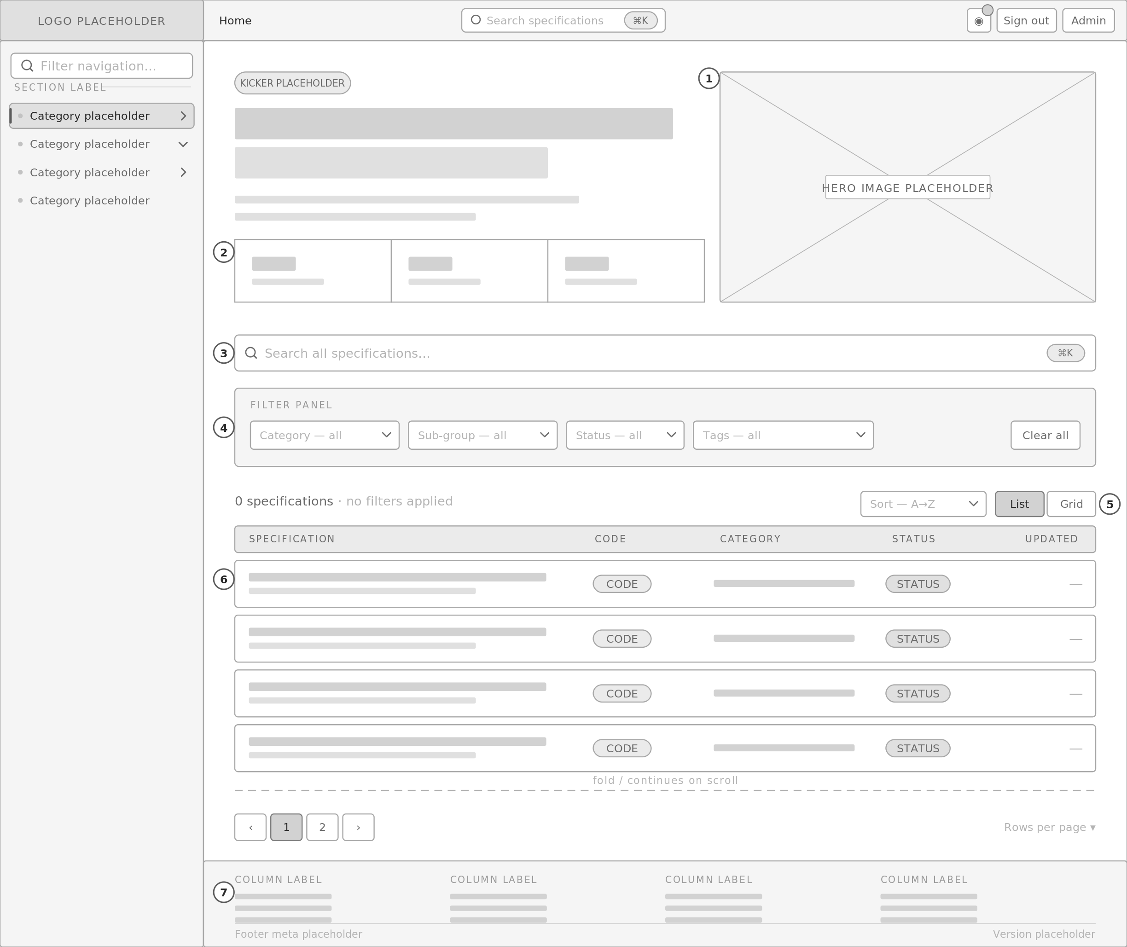
1 Compact hero — kicker, headline, supporting line, three summary tiles, all placeholder. Hero image slot is empty.  2 Summary tiles are computed from data, so they read 0 until the catalogue is populated.  3 Primary search. Full-width, always visible, mirrors the ⌘K palette. This is the fix for the reference system having no search surface on the landing view.  4 Filter panel — category, sub-group, status, tags. All default to 'all'. Selections write to the URL so a filtered view is shareable. |  | 5 Result count, sort control and list/grid toggle. Count is live and reflects filters.  6 Specification list. Columns: title and description, reference code, category, status, last updated. Rows shown as placeholders; the true empty state is plate D16.  7 Footer — four link columns, meta row, version. Absent from the reference system entirely.

D2 Browse — list view
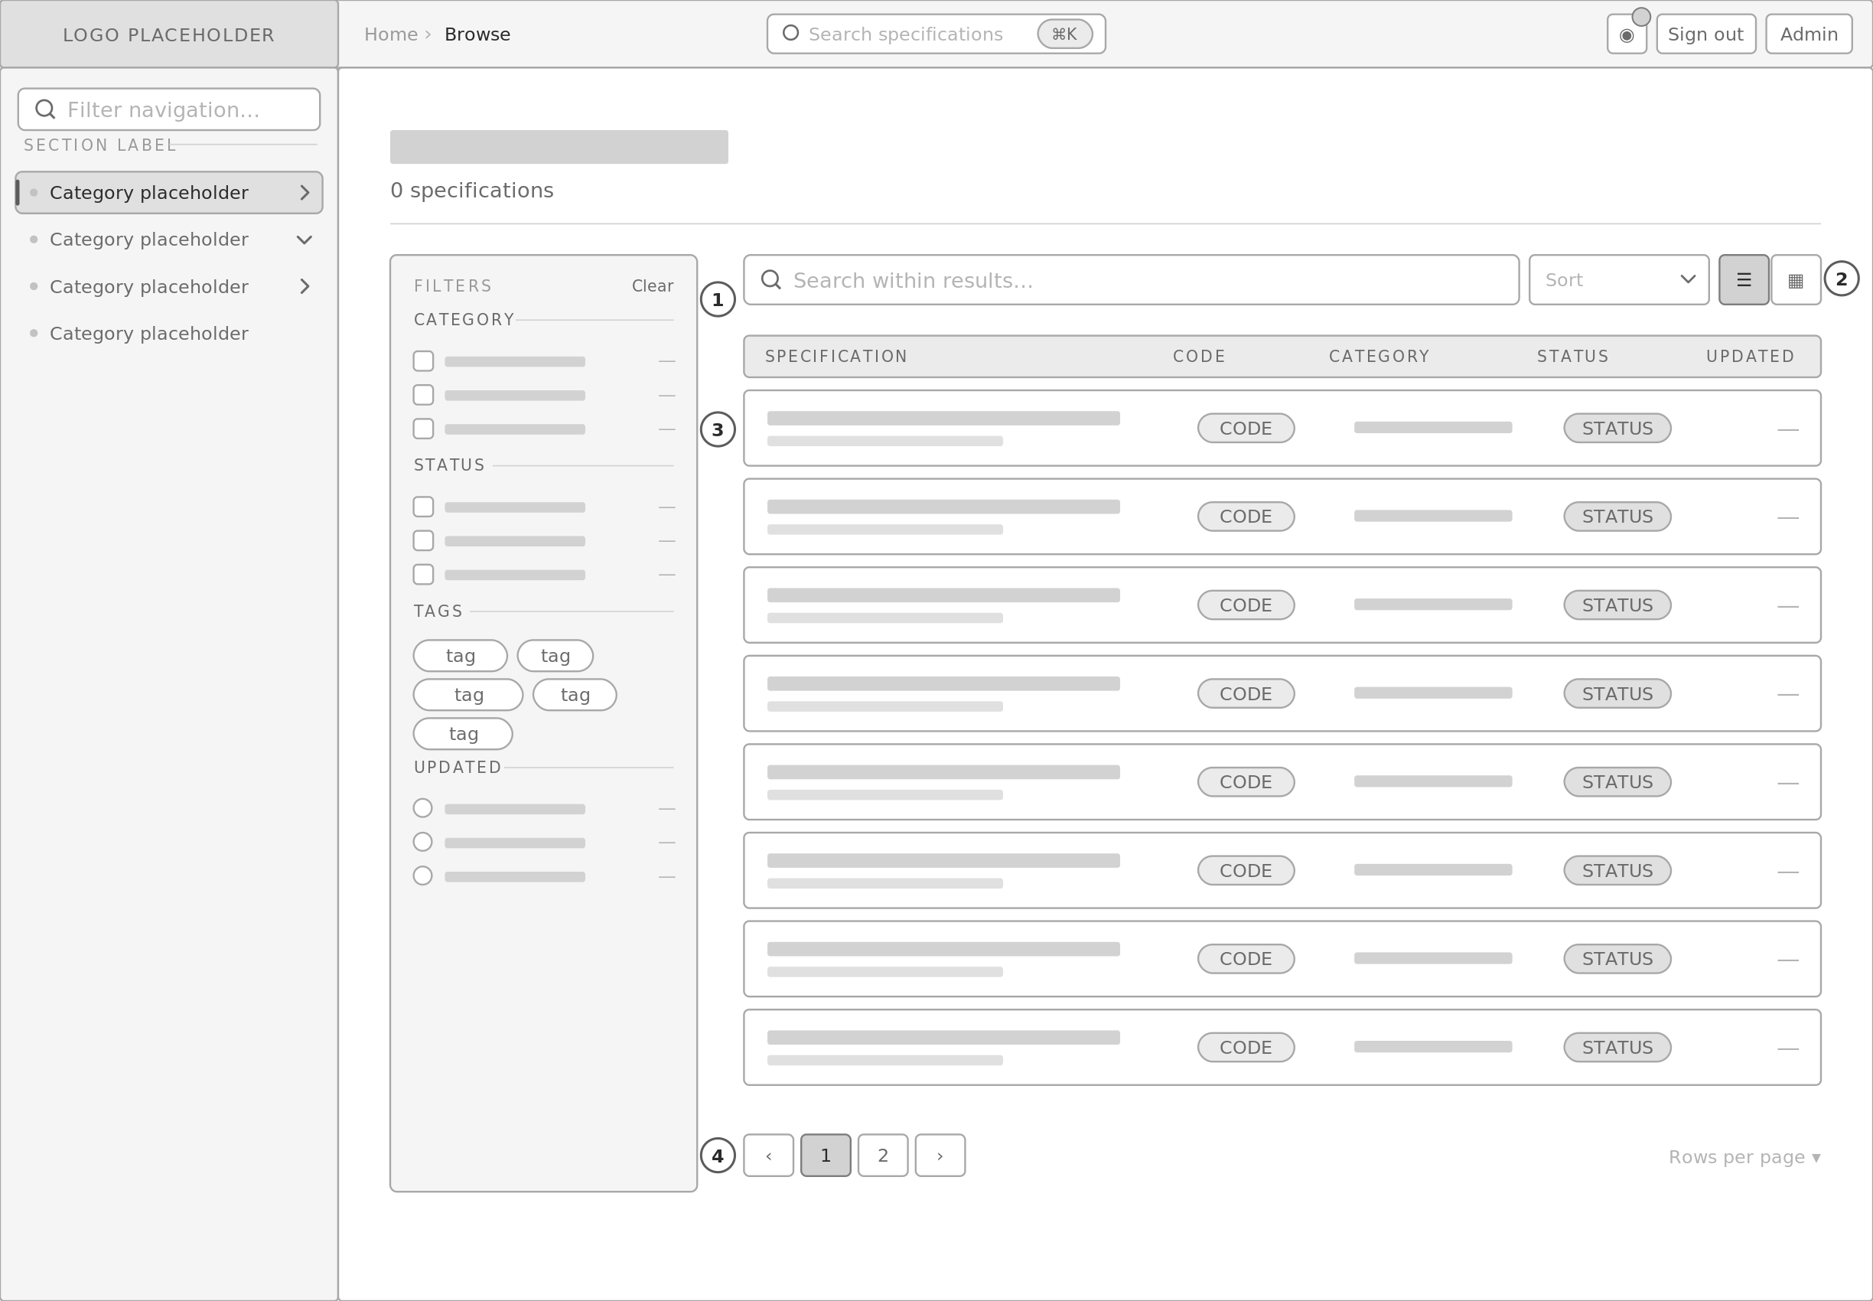
1 Persistent filter rail. Category and status are checkbox groups with live counts (em dash while empty); tags are a chip cloud; updated is a radio group. Independent of the sidebar tree — the tree navigates, the rail filters.  2 Search scoped to the current result set, sort control, and list/grid toggle. The toggle choice persists per device. |  | 3 Result rows. Same column model as the landing list so the two surfaces are learnable as one pattern.  4 Pagination with a rows-per-page control. Lazy loading applies to row images in grid view.

D3 Browse — grid view
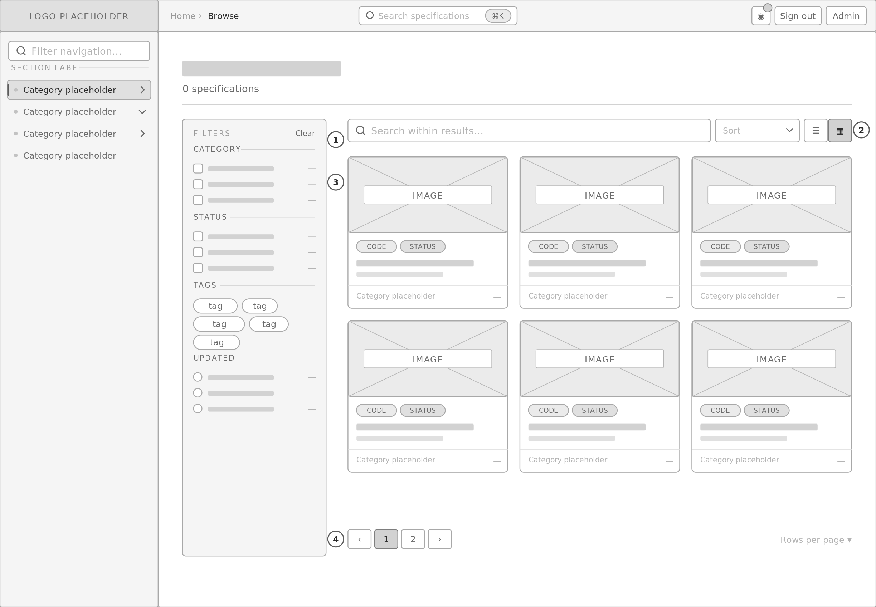
1 Grid card — the component with no precedent in the reference system. Media slot, reference code, status badge, title, supporting line, category footer.  2 Media loads lazily with its aspect ratio reserved, so the grid does not reflow as images arrive. |  | 3 Three columns at 1440, two at 1024, one below 768.  4 Card is a single link target; the whole surface is clickable and focusable as one element.

D4 Category index
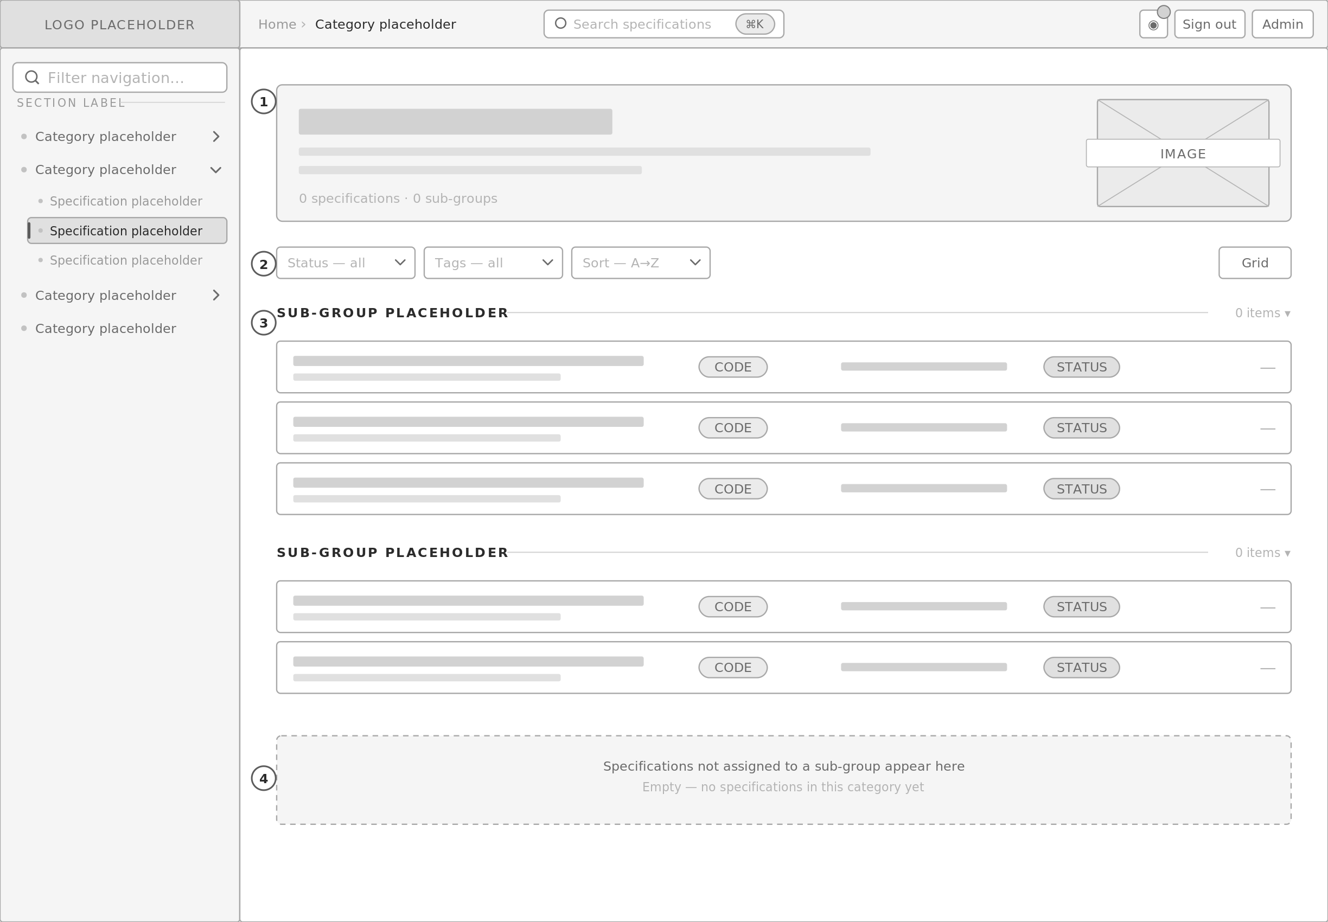
1 Category header — name, description, media slot, counts. All placeholder; counts read 0.  2 Category-scoped filters. Category itself is fixed by the route, so it is absent from this filter row. |  | 3 Sub-group sections. Collapsible, each with its own count. Categories with no sub-groups skip this level entirely — the tier is nullable in the data model.  4 Ungrouped specifications fall into a trailing section, so a category is never partially navigable.

D5 Specification detail — default split-pane
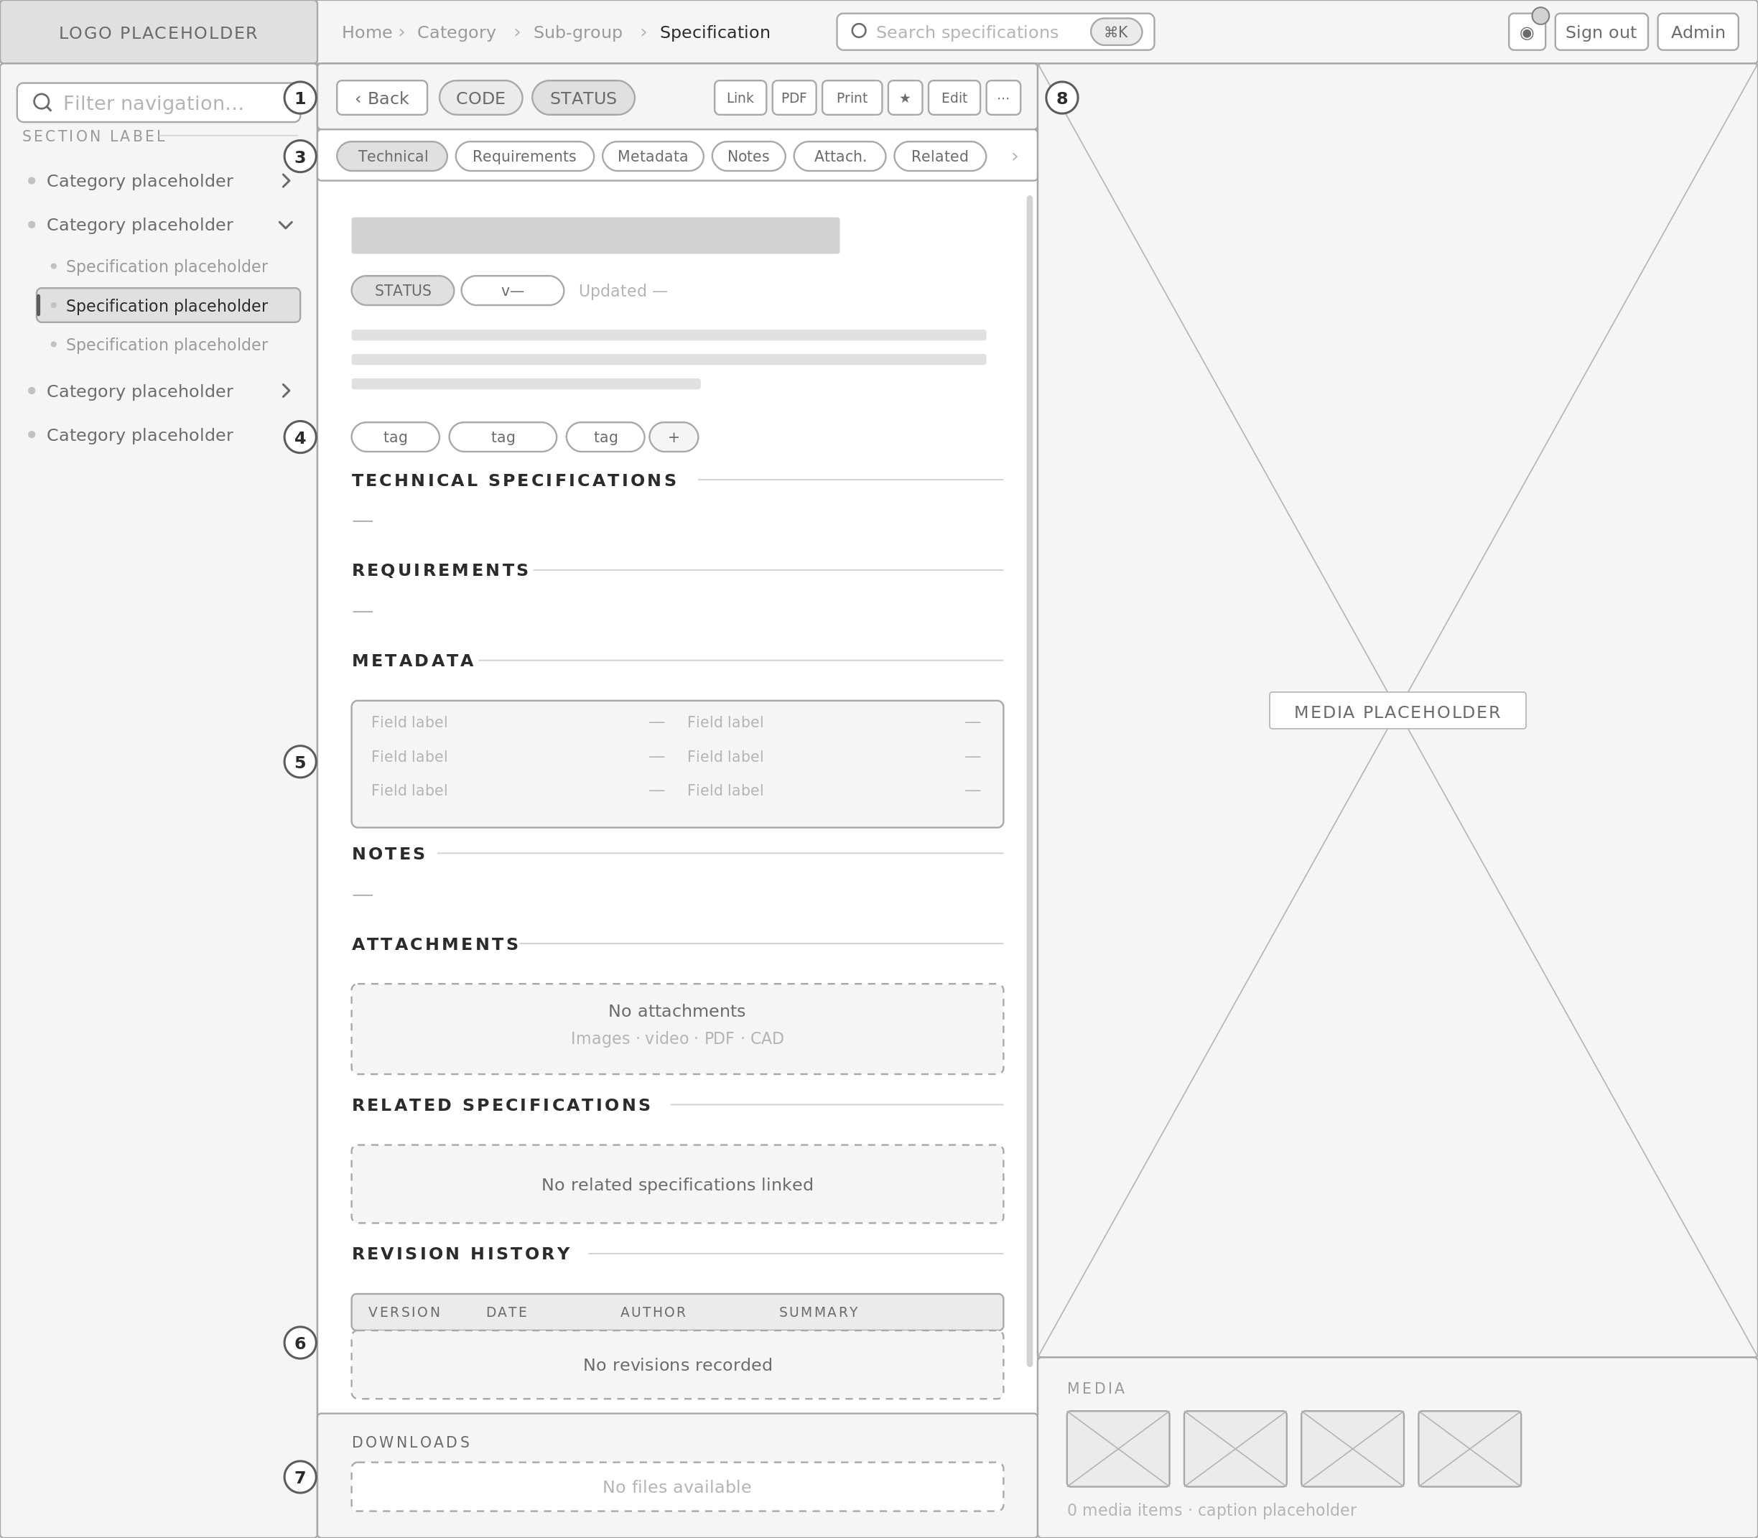
1 Back control and identity: reference code chip and status badge. Both placeholder.  2 Action cluster — copy link, download media, export PDF, print, bookmark, edit, archive. Below 480px these collapse into the overflow menu rather than being removed, which is what the reference system does today.  3 Anchor rail as a horizontal segmented strip inside the panel, with scroll-spy. Keeping it inside the panel is what makes the 50/50 split survive twelve sections — it does not need a third column.  4 Title, status, version, last-updated, description and tags. Every value empty; tags hidden when none exist. |  | 5 Metadata renders as a boxed definition grid — labels present, values em-dashed.  6 Revision history is a real table with header association, not a CSS grid. Empty state sits beneath the header so the column model is still legible.  7 Downloads bar stays pinned to the bottom of the panel at every scroll position — the reference system's strongest interaction pattern, retained.  8 Media pane. Primary slot plus a thumbnail strip and caption, generalised beyond the reference system's single image.

D6 Specification detail — split-pane variants
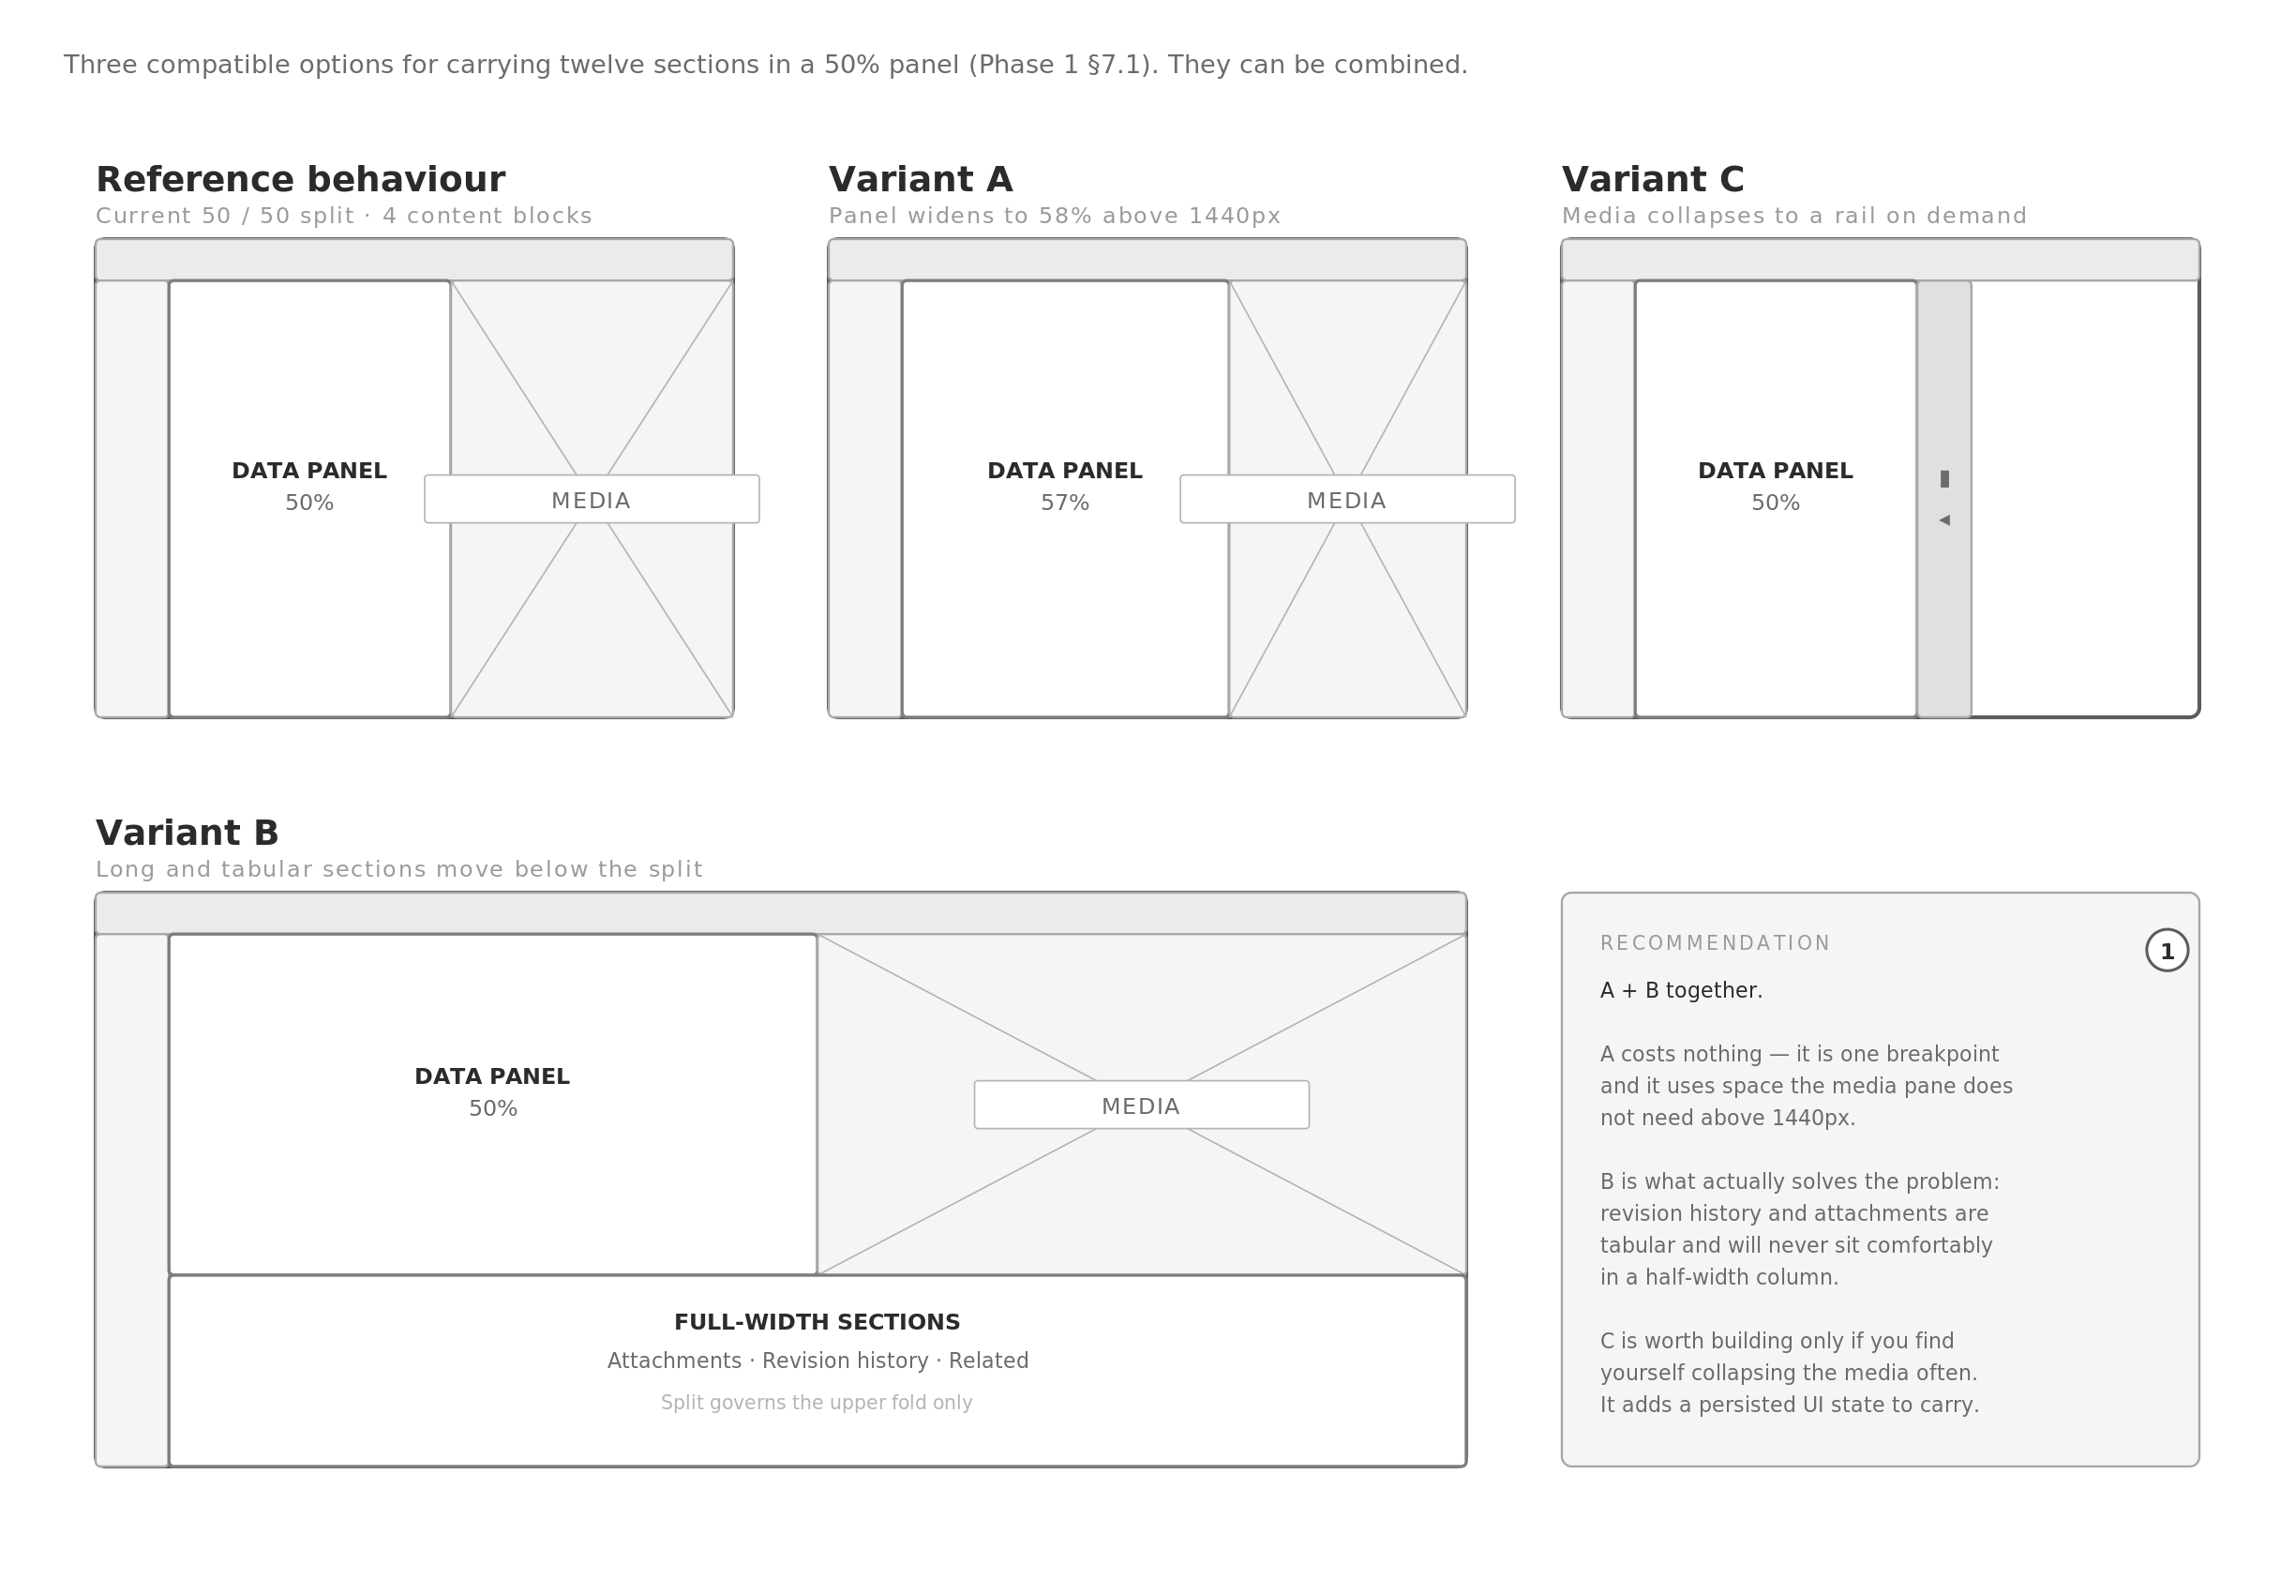
1 Variant A — panel widens from 50% to 58% above 1440px. One media query, no new component, no state.  2 Variant B — attachments, revision history and related specifications render full-width beneath the split. The split then governs only the identity-and-technical fold, which is what users actually scan. |  | 3 Variant C — media pane collapses to a 34px rail, giving the panel full width. Adds a persisted per-device state.  4 Recommendation is A + B. Confirm your preference and it becomes the Phase 3 baseline; the plates in this document show the default split so the comparison is against something concrete.

D7 Global search — command palette
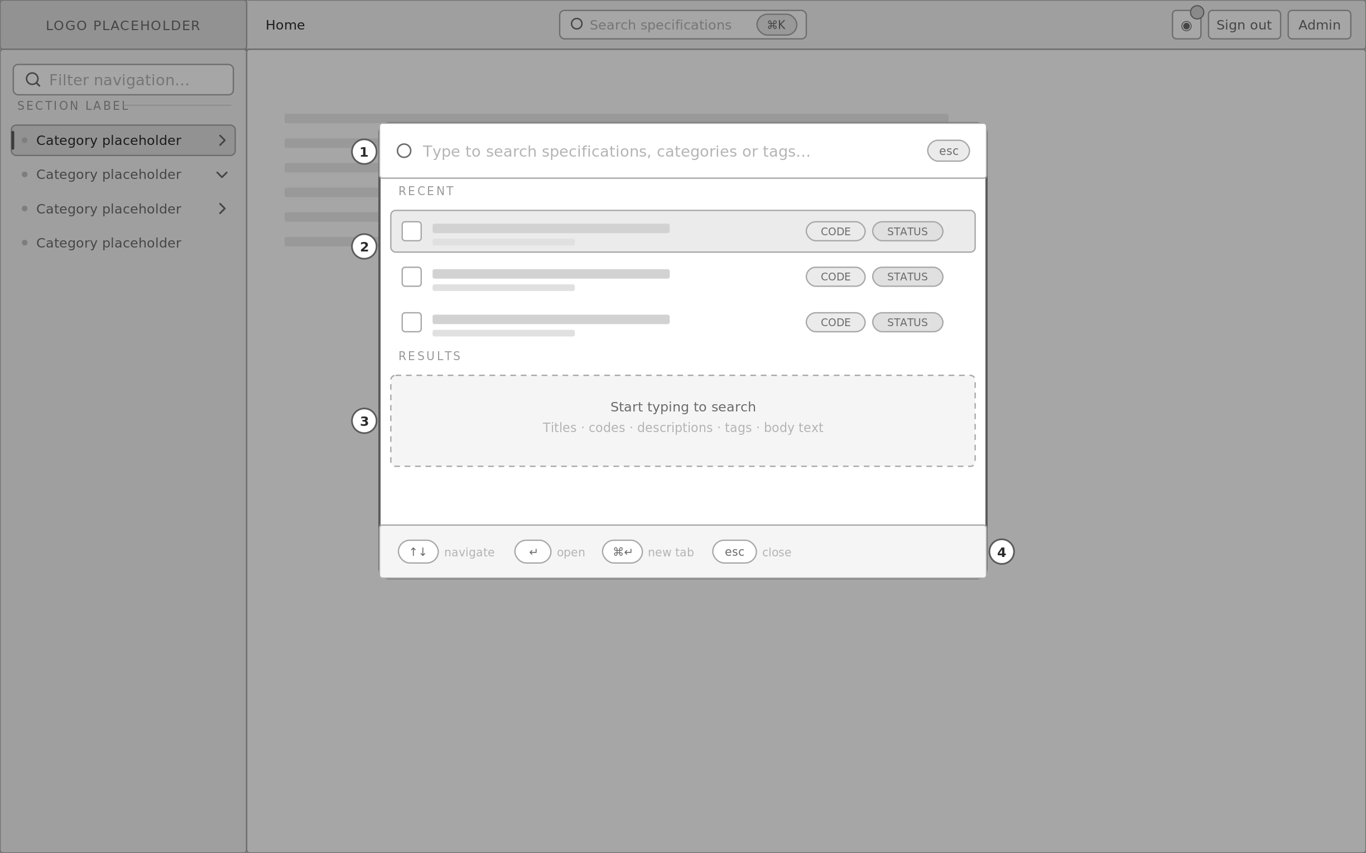
1 Opens on ⌘K / Ctrl-K over any view without navigating away. Escape restores the previous view and returns focus to the trigger.  2 Recent specifications shown before a query is typed, so the palette is useful on open rather than only after input. |  | 3 Search spans titles, reference codes, descriptions, tags and body text — the reference system's sidebar filter matched titles only.  4 Full keyboard operation: arrows to move, enter to open, escape to dismiss. No pointer required at any step.

D8 Search results page
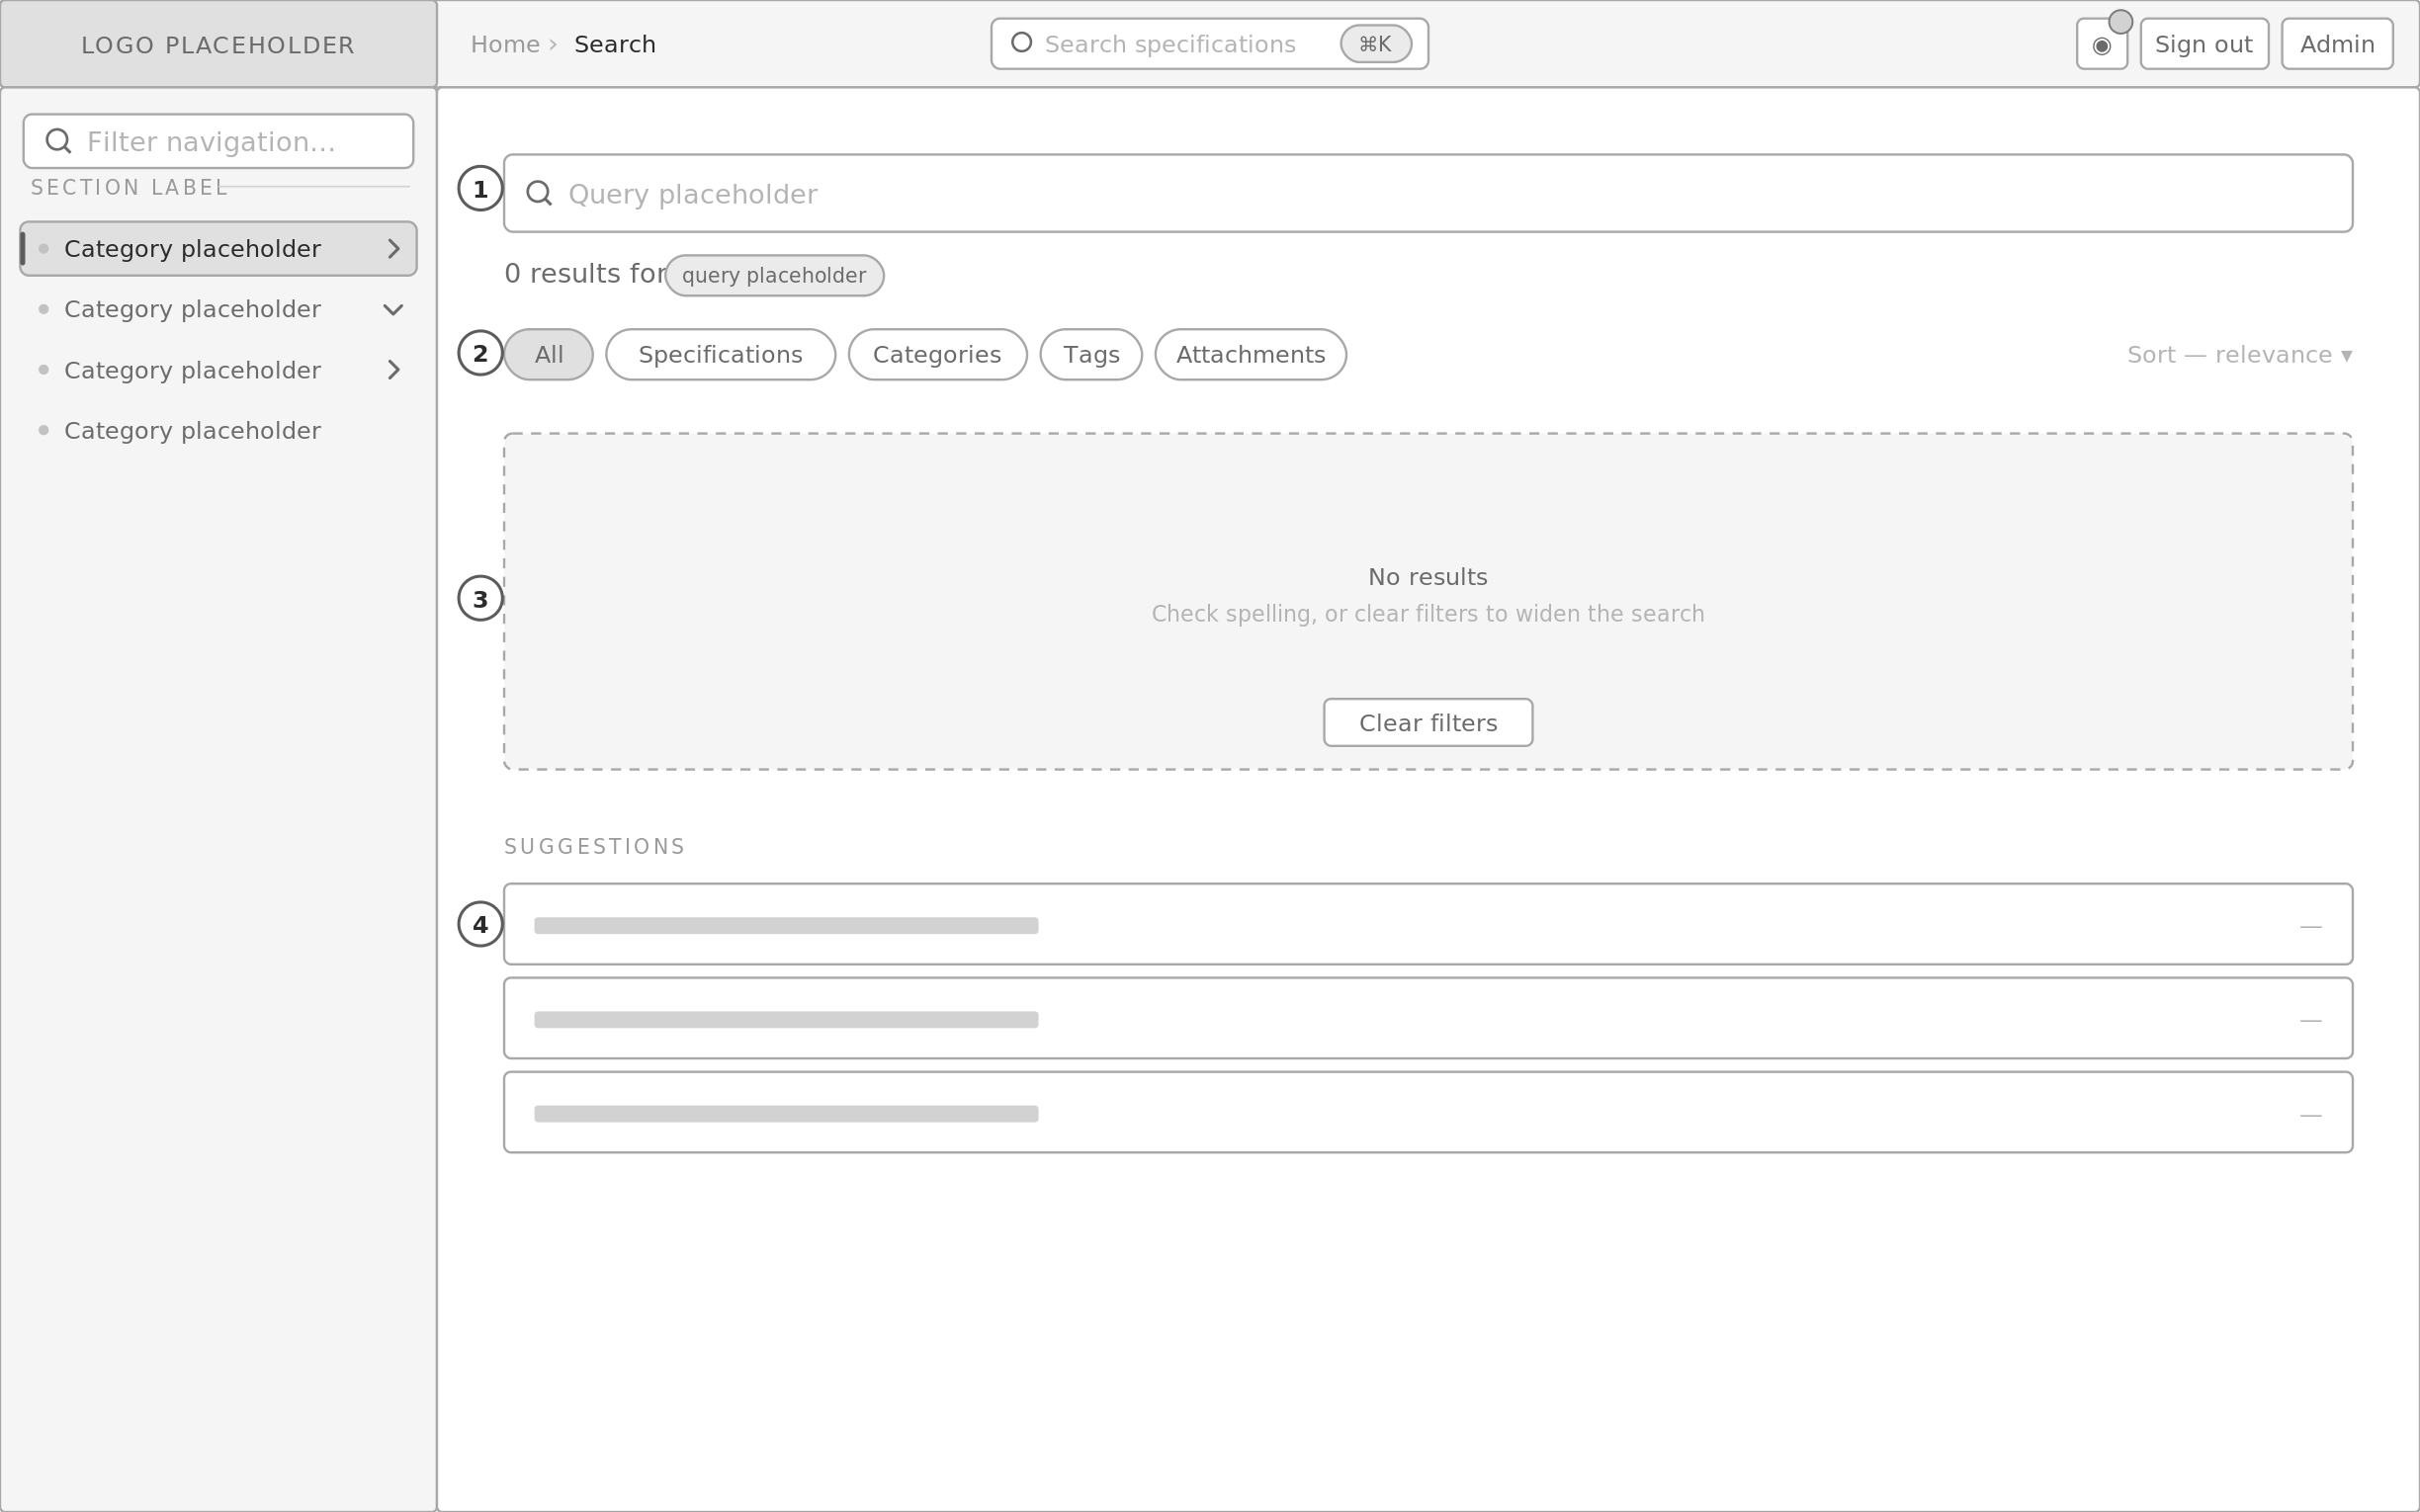
1 The palette's query carries into a full page when the user wants to work through results rather than jump to one. Query is reflected in the URL.  2 Result-type facets. Search reaches beyond specifications to categories, tags and attachment filenames. |  | 3 Zero-result state offers a widening action rather than a dead end.  4 Suggestions surface recently viewed and nearest-match records so the page is never blank.

D9 Bookmarks, favourites and recently viewed
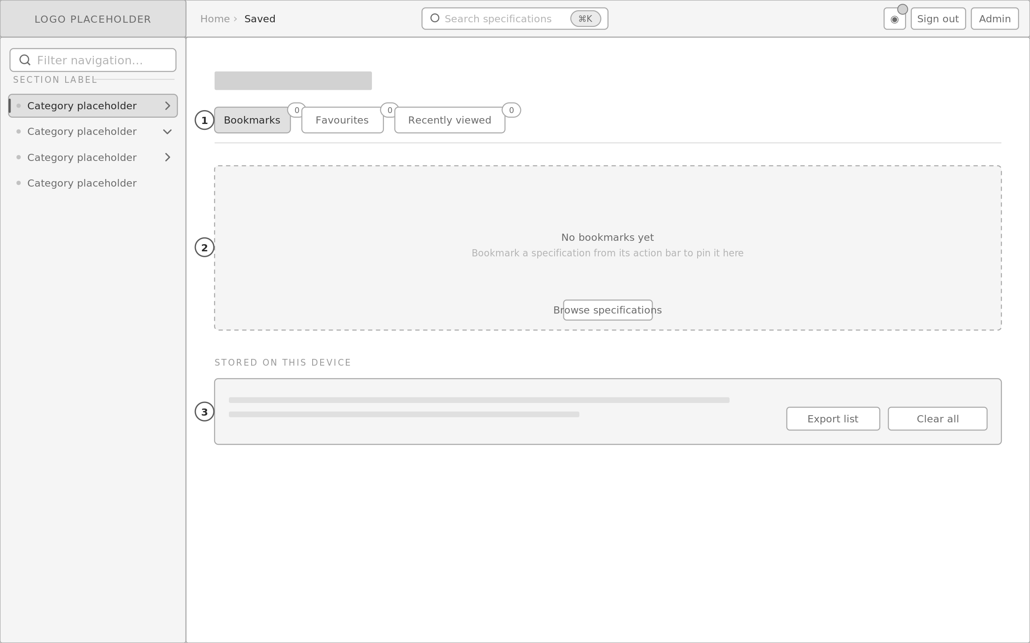
1 Three device-scoped collections behind one tab bar, each with a live count. Derived surfaces — never authored, never part of the category tree.  2 Empty state carries the action that populates it, so the feature is discoverable from the state that would otherwise dead-end. |  | 3 Because these persist per device rather than per account, that is stated plainly with export and clear controls. Phase 5 keeps the storage adapter swappable so they can move to an account later.

D10 Admin — Specs
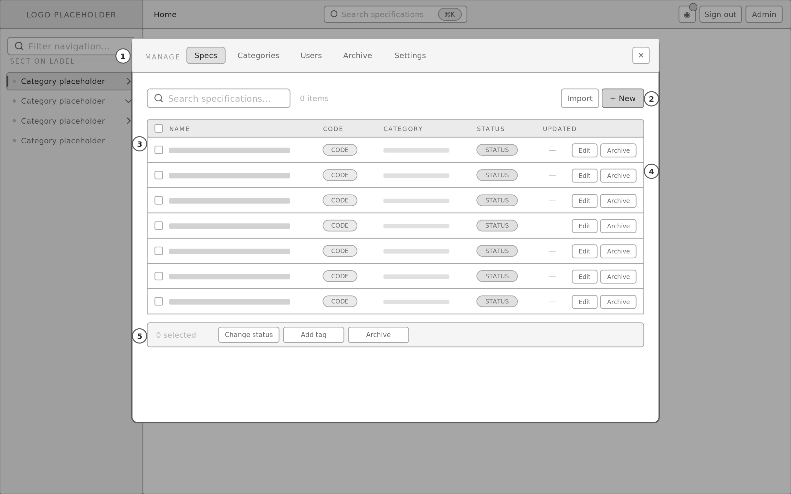
1 Five-tab management sheet, addressable at #/admin/* so a screen can be linked to and reloaded — the reference system's modal has no URL.  2 Search, import and create. Import is the bulk path for populating the catalogue from your existing source.  3 Real table semantics with header association and sortable columns, not the CSS-grid rows the reference system uses. |  | 4 Per-row actions. Archive is soft and reversible; there is no destructive delete outside the Archive tab.  5 Bulk actions bar, absent from the reference system and necessary at the scale you are planning for.

D11 Admin — Categories
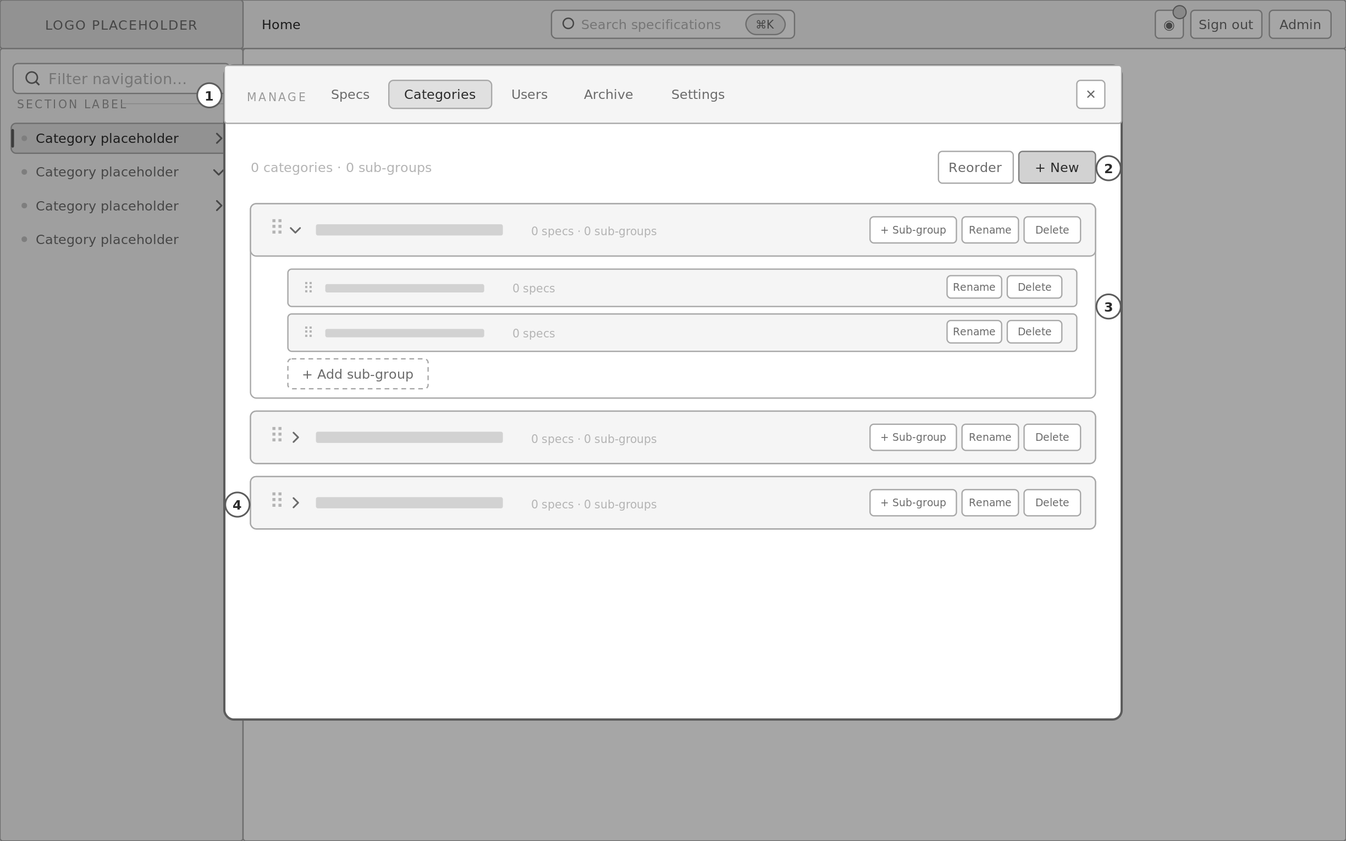
1 Category and sub-group management in one tree, matching the nullable middle tier in the data model.  2 Create and reorder. Order is authored, not alphabetical, because specification catalogues have a conventional sequence. |  | 3 Sub-groups nest inside their category and are drag-reorderable. A category with none simply shows the add affordance.  4 Deleting a category that still holds specifications must prompt for reassignment rather than cascade. That confirmation is specified in Phase 3.

D12 Admin — Users
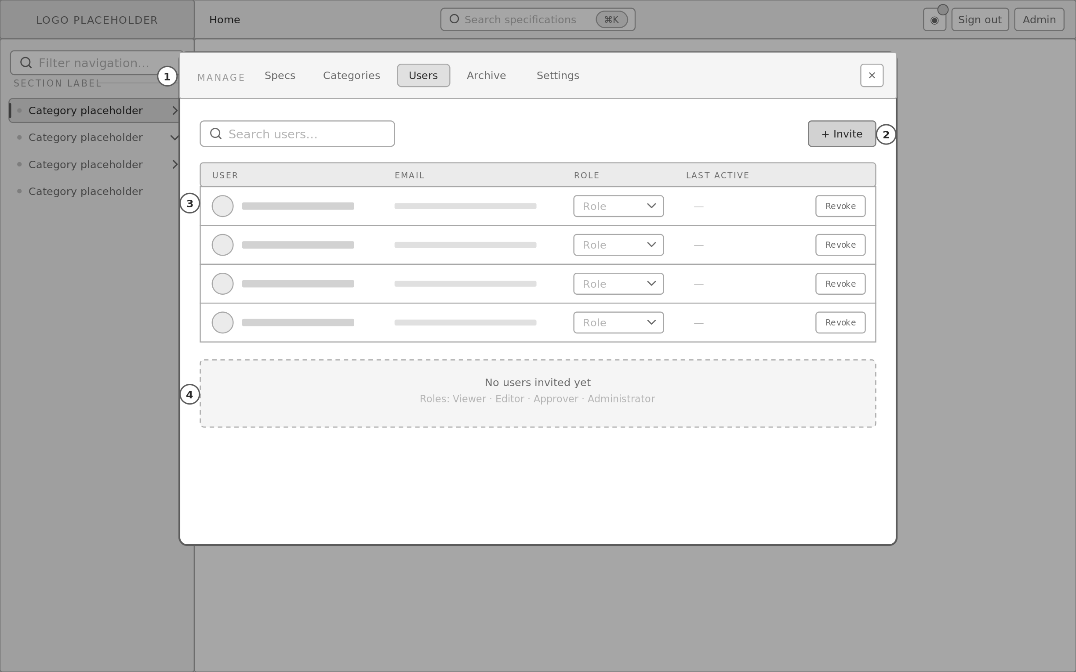
1 User management, present in the reference system as a tab but not built out.  2 Invitation by email rather than account creation in-app. |  | 3 Role is per-user and inline-editable. Four roles carry the approval workflow named in your Phase 9 requirements.  4 Roles are declared here so that Approver exists before workflows are built, rather than being retrofitted later.

D13 Admin — Archive
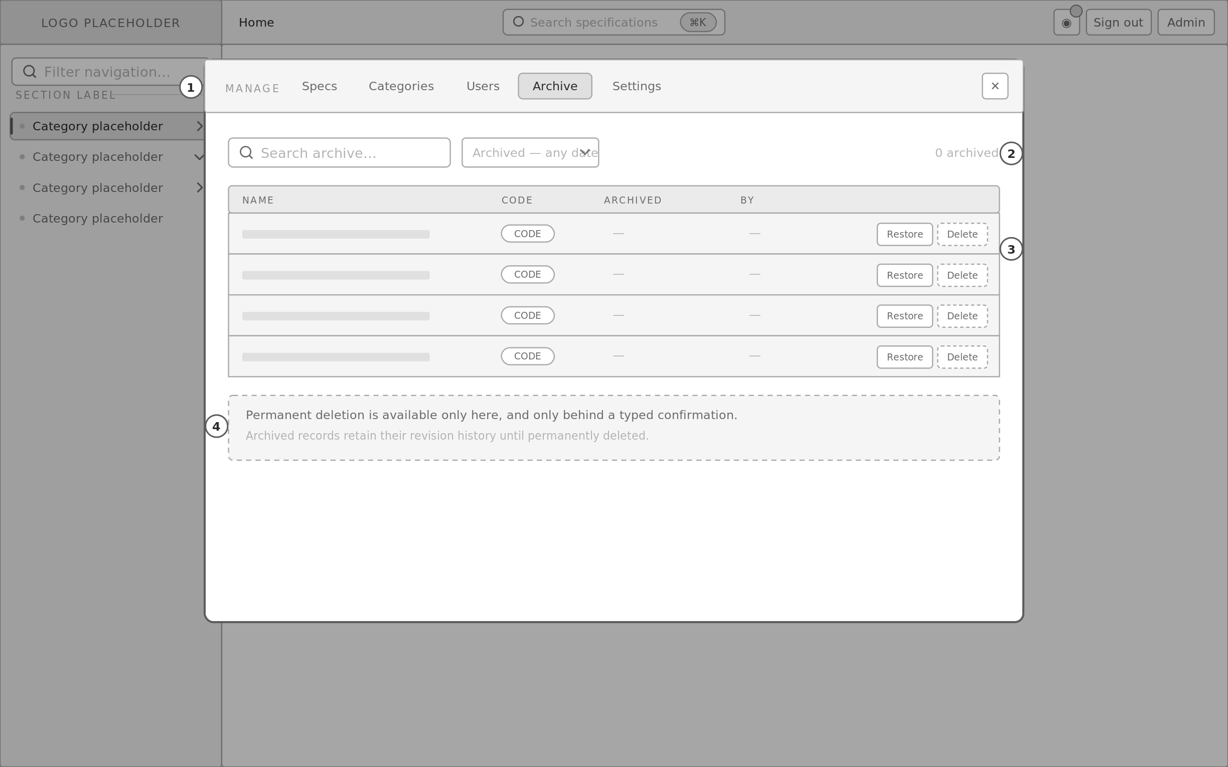
1 Archive as a first-class tab, matching the reference system's soft-delete model.  2 Filterable so an archive of any size stays workable. |  | 3 Restore is one action. Permanent delete is dashed to mark it destructive and is the only irreversible control in the product.  4 Permanent deletion requires typed confirmation. Everything else in the admin layer is reversible.

D14 Admin — Settings
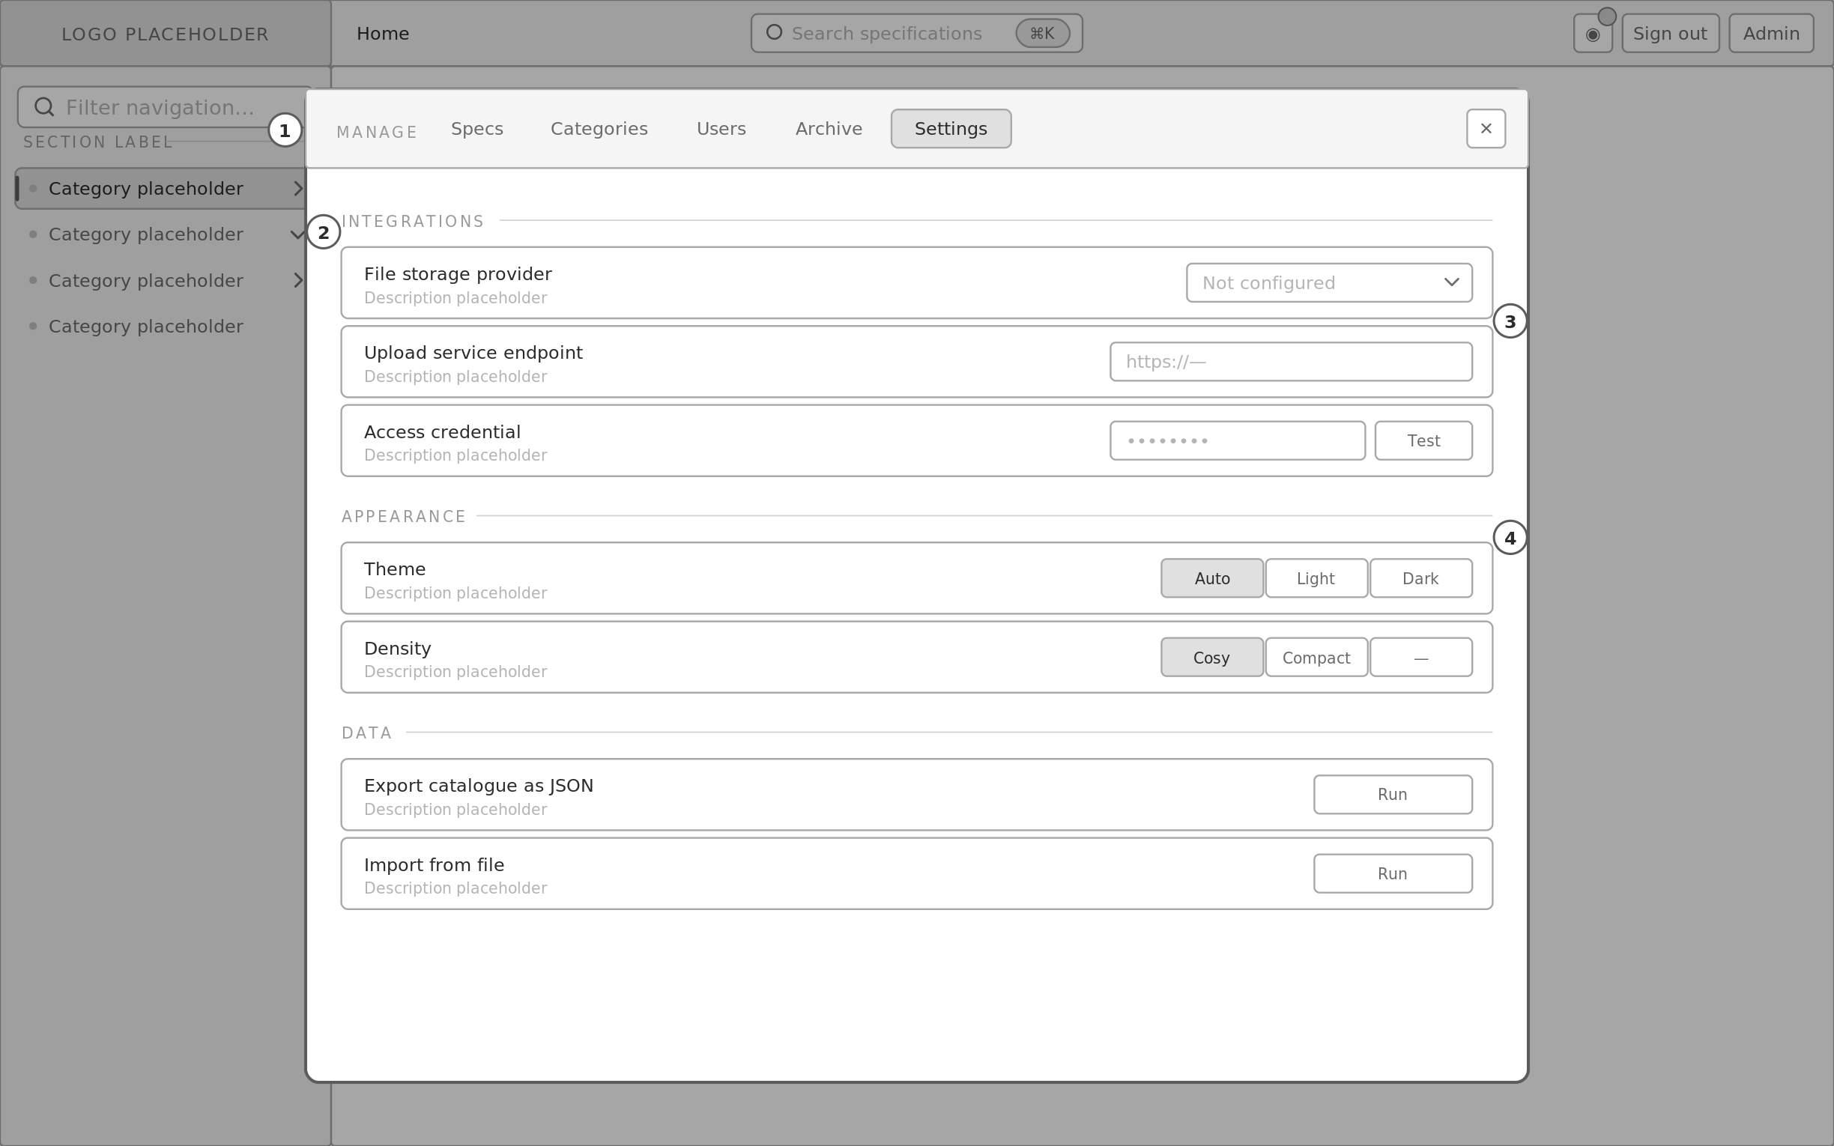
1 Settings, reorganised into integrations, appearance and data.  2 The reference system stores a repository-scoped access token in the browser to commit files. That is replaced by an abstracted upload service — the credential is one adapter behind an interface, not a hard requirement of the product. |  | 3 Theme control is present because the token layer is dual-mode from the start; dark mode is derived, not retrofitted.  4 Export and import make the catalogue portable, which matters while the data source is local files.

D15 Specification editor
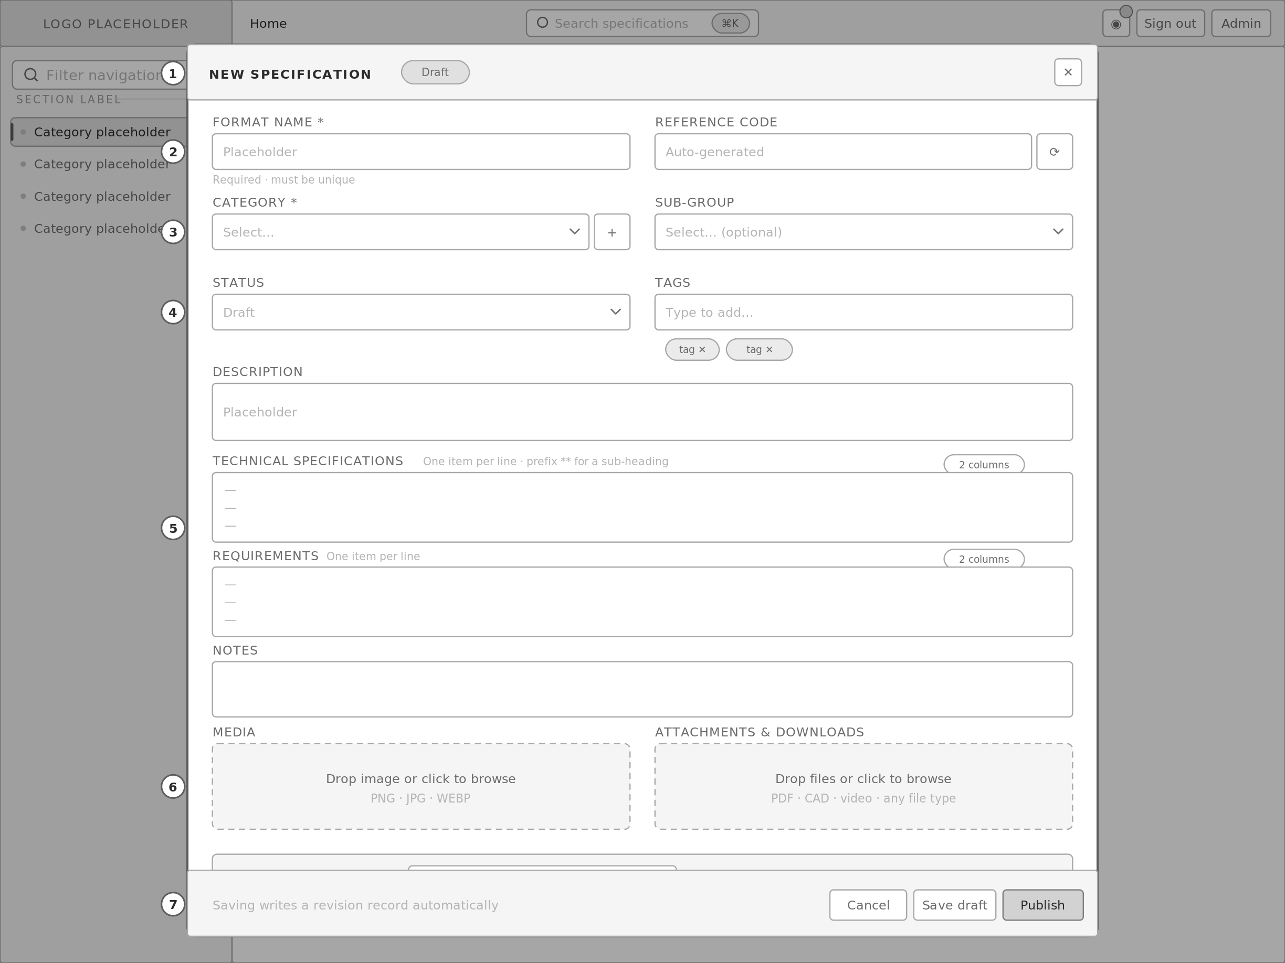
1 Full-height sheet with a live status chip, so the record's state is visible while authoring.  2 Name is required and validated for uniqueness; the message position is reserved beneath the field so the layout does not shift when it appears.  3 Category is required, with inline creation — retained from the reference system, which handles this well. Sub-group is optional, matching the nullable tier.  4 Status and tags. Both are net-new; tags are a token input with removable chips. |  | 5 Line-per-item specification fields with the double-asterisk sub-heading convention and the two-column toggle, both carried over from the reference system.  6 Two drop zones. Media is images only; attachments accept any file type — generalised beyond the reference system's PDF-only handling.  7 Save draft and publish are separate actions. Every save writes a revision record, so history is a by-product of authoring rather than a separate chore.

D16 System states
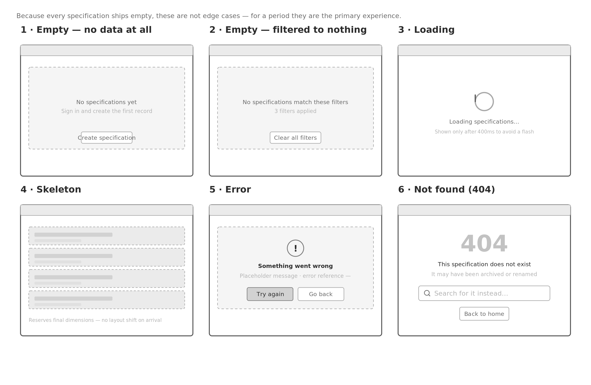
1 Empty with no data — the shipping state. Carries the action that resolves it.  2 Empty after filtering — distinct from the above, because the resolution is different. Naming the filter count prevents the user assuming the catalogue is empty.  3 Loading — delayed 400ms so fast responses never flash a spinner. |  | 4 Skeleton — used wherever final dimensions are known, which is every list and card surface. Prevents layout shift.  5 Error — states what happened, offers a retry, and carries a reference for support.  6 404 — offers search rather than only a link home, because a dead specification link usually means the record was renamed rather than removed.

R1 Landing — tablet & mobile
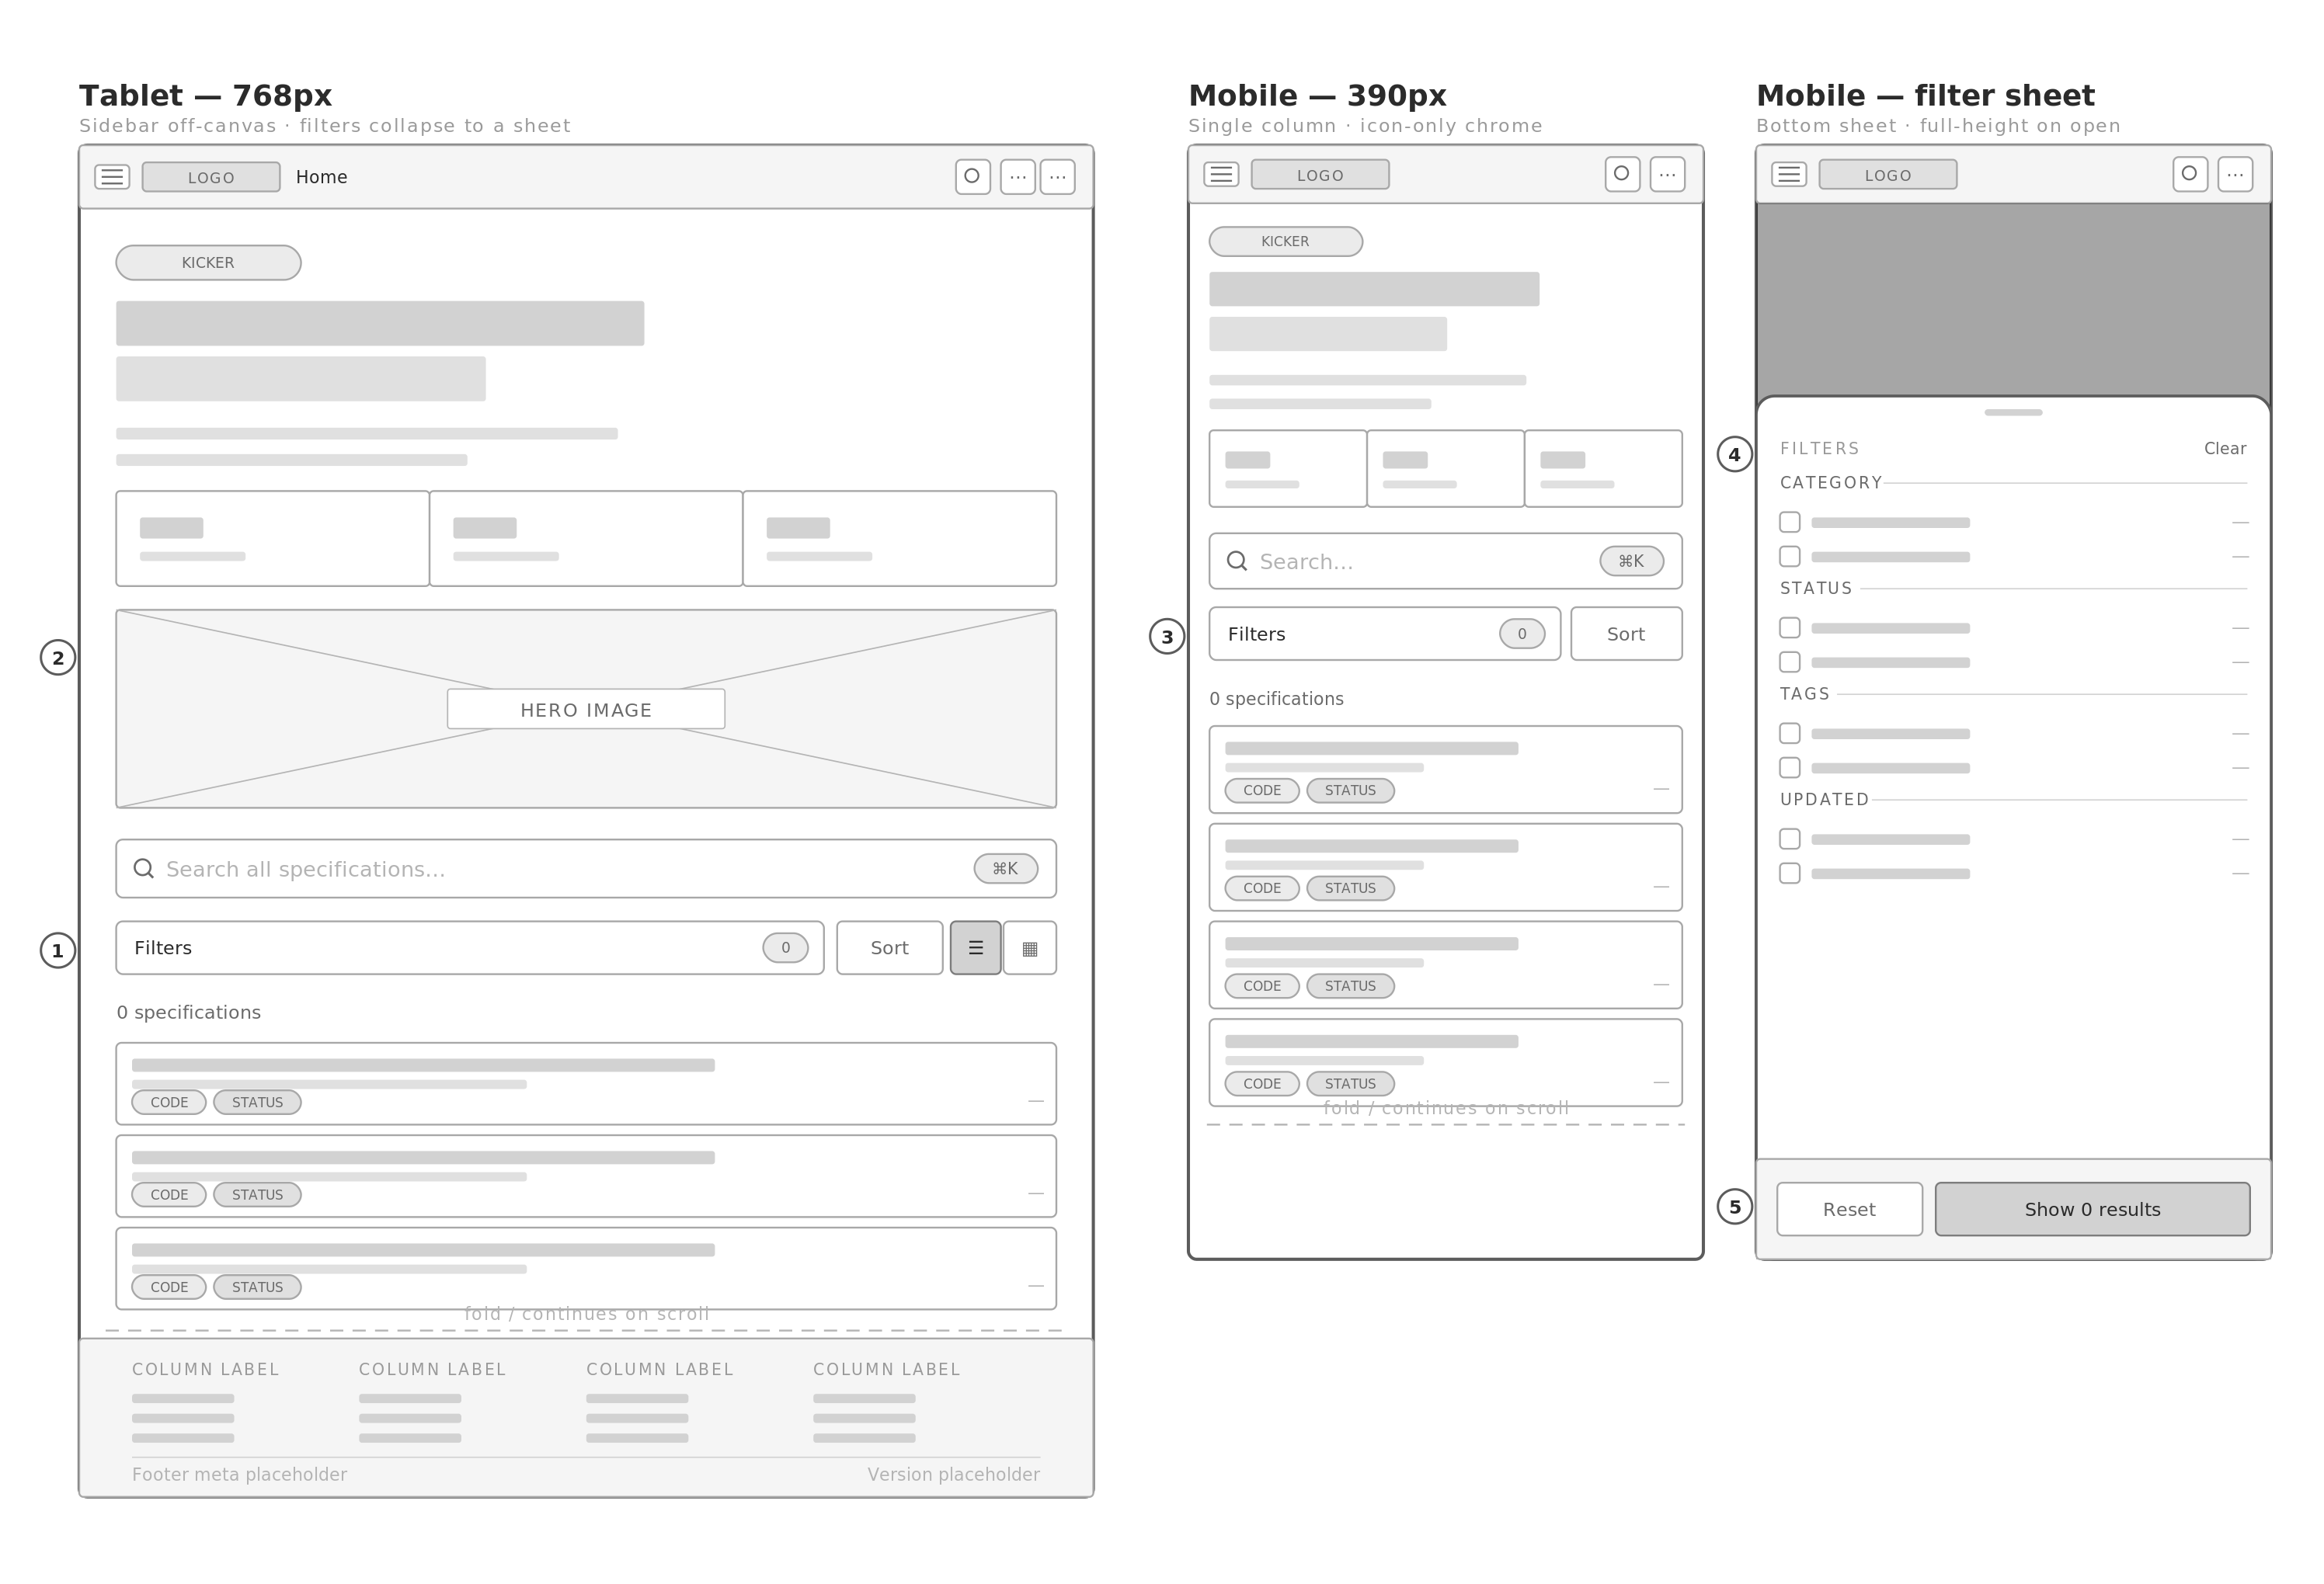
1 At 768px the sidebar leaves the flow and becomes an off-canvas overlay behind a hamburger. Content takes the full width.  2 The hero image moves below the text rather than beside it, and the three statistic tiles distribute evenly.  3 At 390px the filter panel collapses to a single button. Nothing is removed — the reference system hides controls at this width; here they relocate. |  | 4 Filters open as a bottom sheet with a drag handle, reaching full height. Groups keep the same order as the desktop rail so the mental model is identical.  5 Sheet actions are pinned. The primary action states the result count, so the user knows the outcome before dismissing.

R2 Browse — tablet & mobile
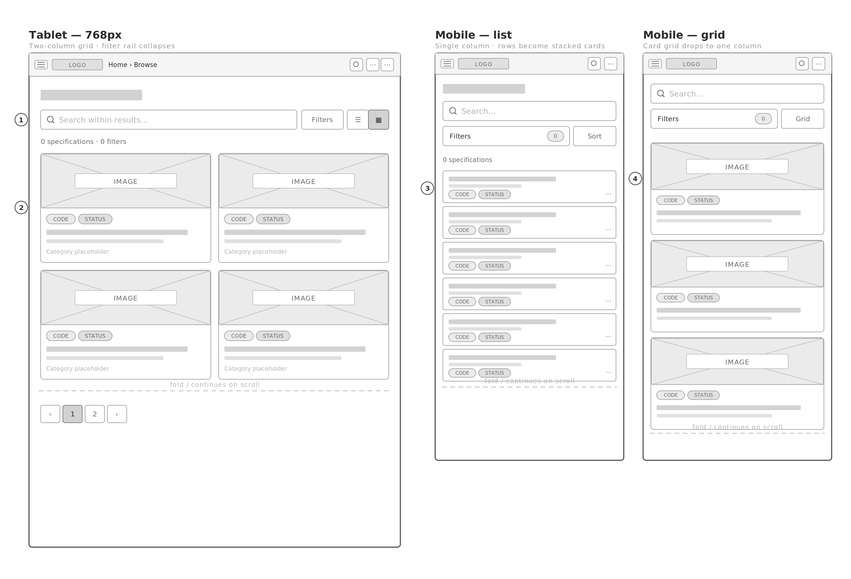
1 Filter rail collapses to a button at 768px. The results area takes the recovered width rather than the layout simply narrowing.  2 Card grid drops from three columns to two at 1024px and to one below 768px. |  | 3 List rows restructure rather than truncate — title, supporting line, then code and status on a second row. Nothing relies on horizontal scrolling.  4 Grid and list toggle persists per device, so the choice survives navigation.

R3 Specification detail — tablet & mobile
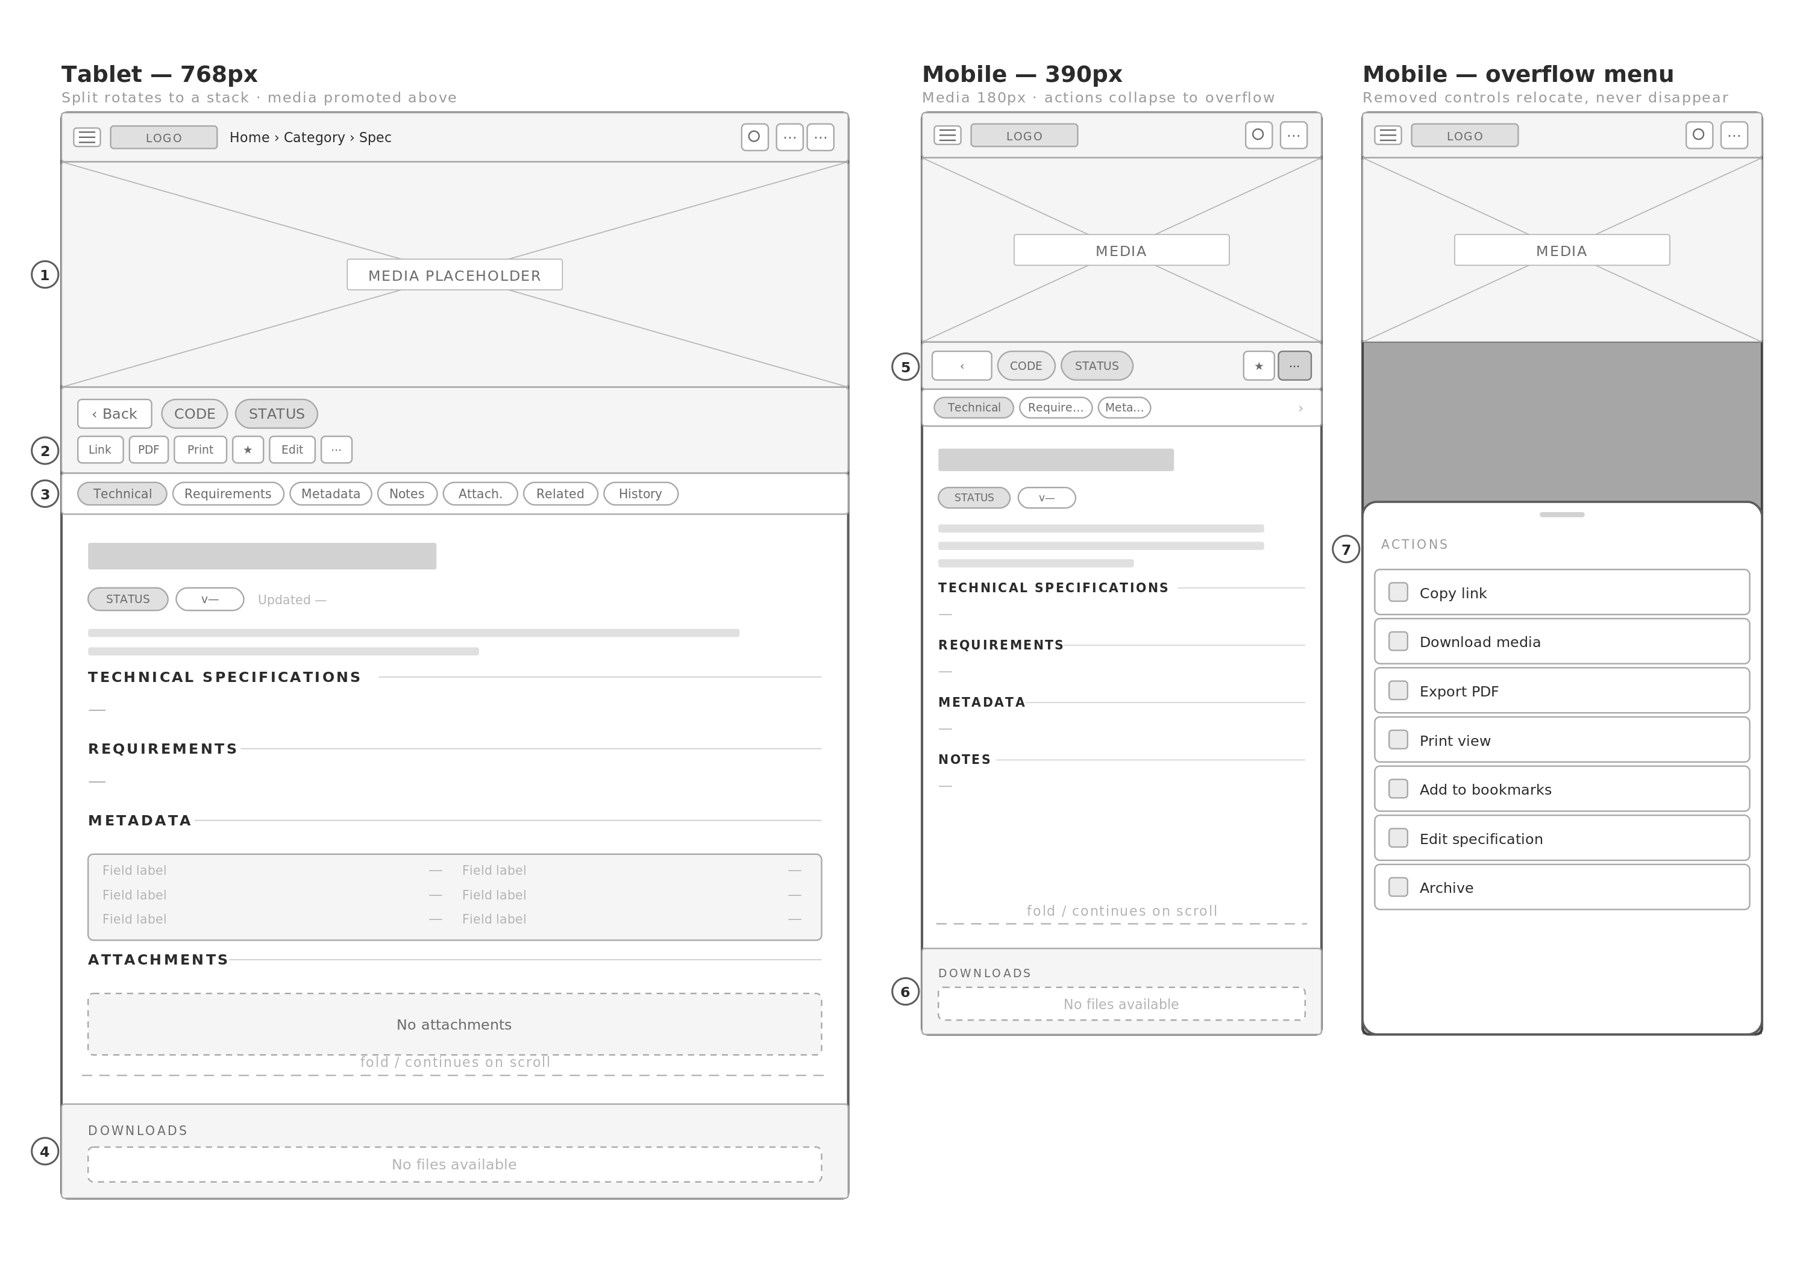
1 Below 1024px the split rotates: media is promoted above the data panel at a fixed height, and the page scrolls as a document rather than as panes. This matches the reference system's behaviour and is retained.  2 The action bar wraps to a second row rather than dropping controls.  3 The anchor rail becomes a horizontally scrollable strip and keeps scroll-spy. It is the main reason the twelve sections stay navigable on a small screen.  4 The downloads bar stays pinned at every width — the one element that never moves. |  | 5 At 390px the action bar keeps back, code, status, bookmark and overflow only.  6 Section labels compress but keep the flexing rule, so the reading rhythm is unchanged.  7 Everything removed from the bar appears in the overflow sheet with a full text label. This is the correction to the reference system, which deletes the image-download control entirely below 360px.

R4 Navigation overlay & palette — tablet & mobile
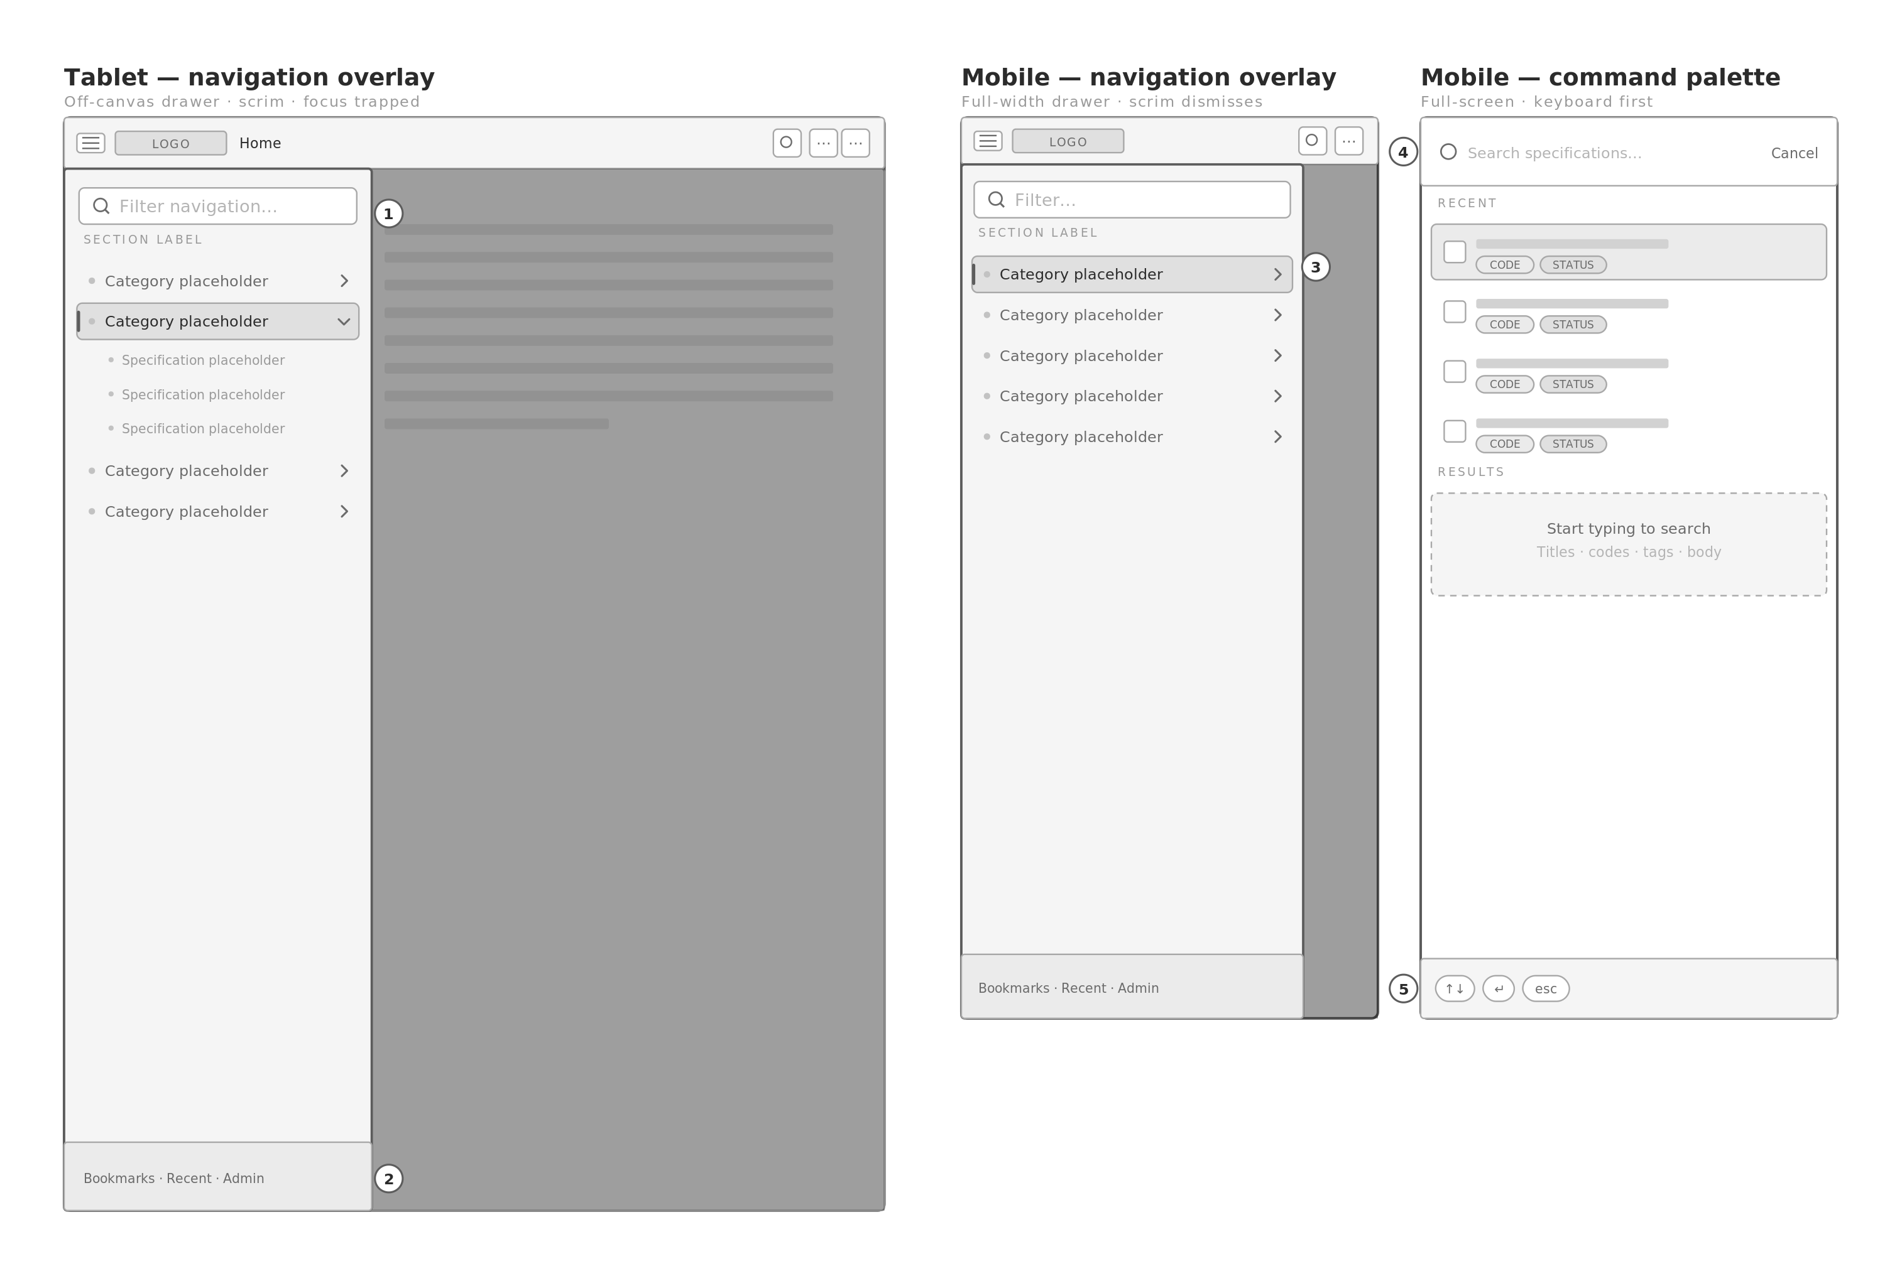
1 The off-canvas drawer is conditionally rendered and marked inert when closed, so its controls leave the tab order. The reference system translates the panel off-screen, leaving every button focusable while invisible.  2 A persistent footer in the drawer carries bookmarks, recent and admin, which have no room in the top bar at these widths.  3 Selection state — accent fill plus the left edge bar — is identical to desktop, so the tree is recognisable across breakpoints. |  | 4 The palette goes full-screen on mobile rather than floating, and gives the field immediate focus.  5 Keyboard hints persist on mobile because these views are used with external keyboards on tablets.

R5 Editor & admin — tablet & mobile
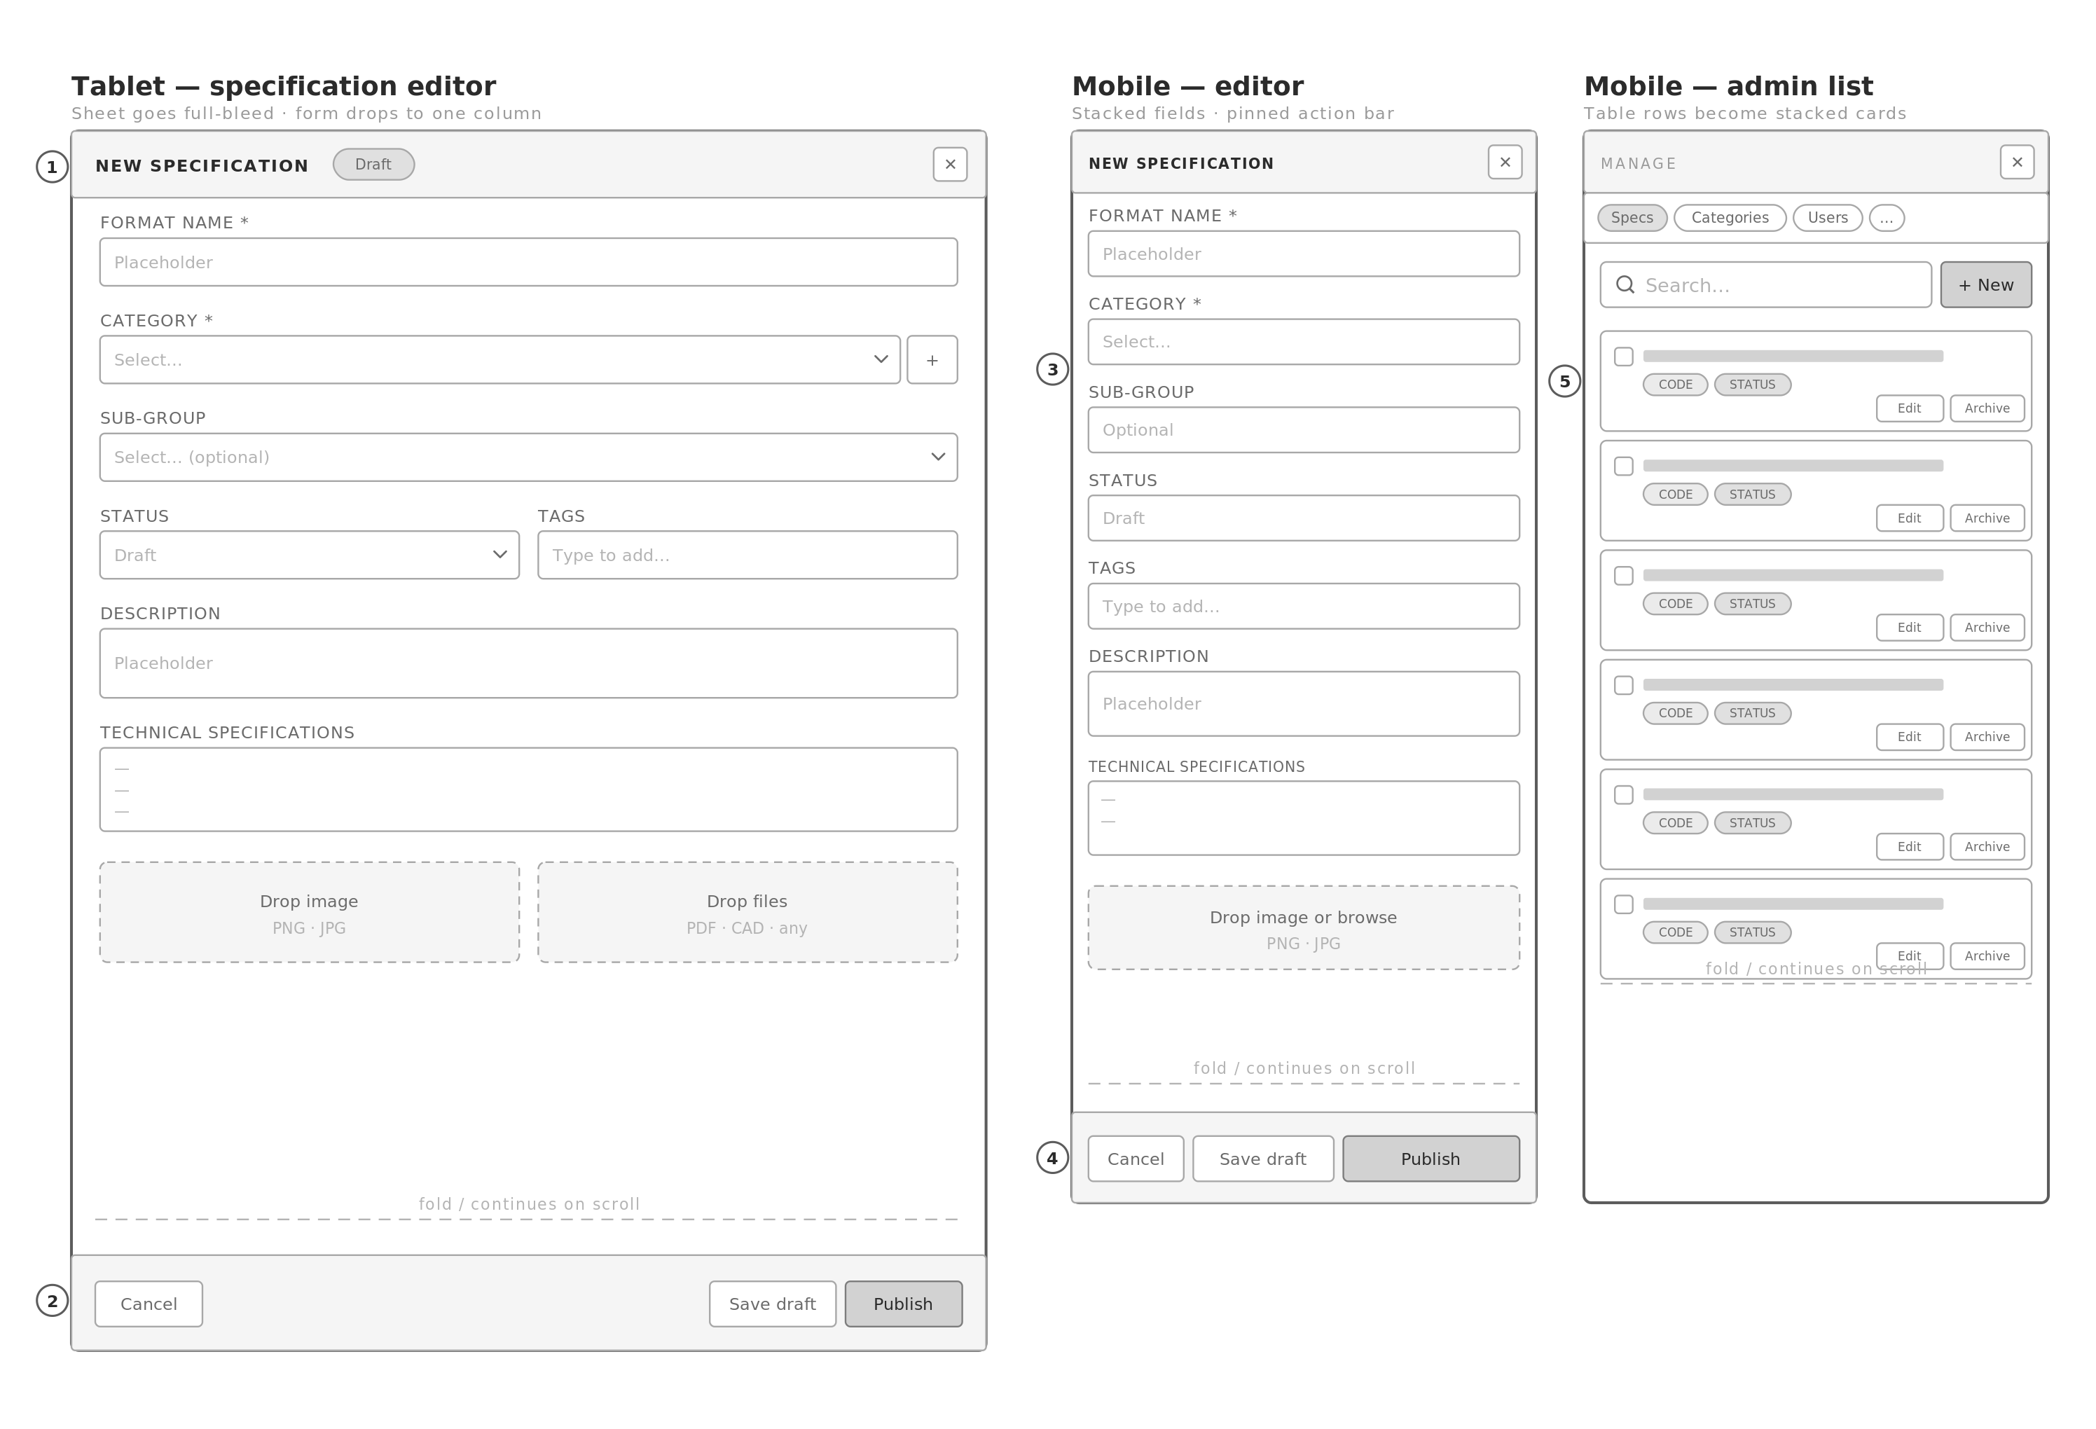
1 The editor sheet goes full-bleed at 768px and the two-column form collapses to one, matching the reference system's behaviour.  2 Save and publish stay pinned to the bottom at every width, so a long form never hides its primary action.  3 Field labels stay above their inputs rather than beside them, which keeps touch targets full-width and label association unambiguous. |  | 4 Three actions fit at 390px because publish takes the remaining width rather than a fixed one.  5 Admin table rows become stacked cards below 768px — a real responsive table pattern, not a horizontal scroll. Selection checkbox and per-row actions are preserved.

Responsive adaptation summary
What changes at each breakpoint, and why. Every row is a deliberate decision rather than a consequence of the layout narrowing.

Element | 1440 — desktop | 768 — tablet | 390 — mobile
Sidebar | 260px, persistent, in flow | Off-canvas overlay behind a hamburger, with scrim | Full-width drawer, 320px, with a persistent footer for bookmarks, recent and admin
Top bar | 52px, breadcrumb, palette, admin, sign out | 48px, breadcrumb truncates, palette becomes an icon | 44px, logo and icons only, breadcrumb replaced by the back control
Landing filters | Inline filter panel, always visible | Collapses to a Filters button with a sheet | Filters button only; sheet reaches full height with a drag handle
Specification detail | 50 / 50 split, panes scroll independently | Split rotates to a stack, media promoted above at 220px, document scrolls | Media 180px, action bar reduces to back, code, status, bookmark and overflow
Anchor rail | Horizontal segmented strip inside the panel | Same, horizontally scrollable | Same, three chips visible with a scroll affordance
Downloads bar | Pinned to the panel base | Pinned to the viewport base | Pinned to the viewport base — never moves at any width
Browse grid | Three columns | Two columns | One column
Admin tables | Semantic table, sortable, bulk-selectable | Same, horizontally constrained columns drop | Rows become stacked cards; selection and per-row actions preserved
Editor form | Two columns in a 1020px sheet | One column, sheet goes full-bleed | One column, labels above inputs, actions pinned to the base
Overflow actions | All actions visible in the bar | Bar wraps to a second row | Overflow sheet with full text labels — nothing is removed

Correction to the reference system
The reference system removes controls as the viewport narrows — the image-download control disappears entirely below 360px, and button labels vanish at 480px leaving unlabelled icons.
Every plate here relocates instead of removing. The overflow sheet on plate R3 is where those controls go, and they carry full text labels there.

Accessibility decisions carried into these wireframes
The Phase 1 findings are structural, so several are already fixed in the wireframes rather than deferred to Phase 3.

Phase 1 finding | How the wireframes resolve it
Collapsed accordions and the closed off-canvas nav stay focusable | Plate R4 shows the drawer as conditionally rendered and inert when closed. Collapsed tree branches are removed from the DOM, not hidden by overflow.
Accordion max-height ceiling clips branches over 600px | No fixed ceiling appears in any plate. Branch height is measured, so a category with two hundred specifications expands correctly.
Admin grid rows are not semantic tables | Plates D10–D13 show real header rows with column association, sort affordances and a selection column.
Controls removed rather than relocated on small screens | Plate R3 introduces the overflow sheet. No control is absent at any breakpoint.
Type scale bottoms out at 8px; tertiary text fails contrast | Deferred to Phase 3, where the token layer is defined — but no plate depends on type below the corrected floor to remain legible.
No visible focus styling | Focus rings are a Phase 3 primitive. The wireframes reserve space for them by keeping 4px of clearance around every interactive element.
No empty, loading, error or skeleton states | Plate D16 defines all six. Because the catalogue ships empty, these are treated as primary rather than as edge cases.

Phase 3 scope & approval
On approval of these wireframes, Phase 3 produces the design system: typography, spacing scale, grid, containers, cards, buttons, inputs, tables, badges, tags, accordions, modals, navigation, sidebars, breadcrumbs, alerts, tooltips, icons, and the empty, loading, error and skeleton states shown on plate D16. Every item is defined as a component with variants, states, tokens and accessibility notes.

Decisions needed before Phase 3 begins
- Split-pane variant. Plate D6 presents three options. The recommendation is A + B — widen the panel above 1440px, and move attachments, revision history and related specifications full-width beneath the split. Confirm or choose otherwise.
- Landing hero. Plate D1 keeps a compact hero above the browse surface. The alternative is to drop the hero entirely and open straight into the list, which suits a returning-user portal better but loses the front door.
- Status vocabulary. The plates show a placeholder badge throughout. Phase 3 needs the actual set — Draft, In review, Published, Deprecated, Superseded is a reasonable default if you have no existing convention.
- Metadata fields. Plate D5 reserves six metadata rows. The field names are yours to define; the count drives the boxed grid layout.

Approval
No final UI will be produced until these wireframes are approved. If the structure of any screen is wrong, it is far cheaper to correct it here than after the design system is built on top of it.

End of Phase 2. Deliverables 5–6 of 12 complete. Awaiting approval to proceed to Phase 3.

